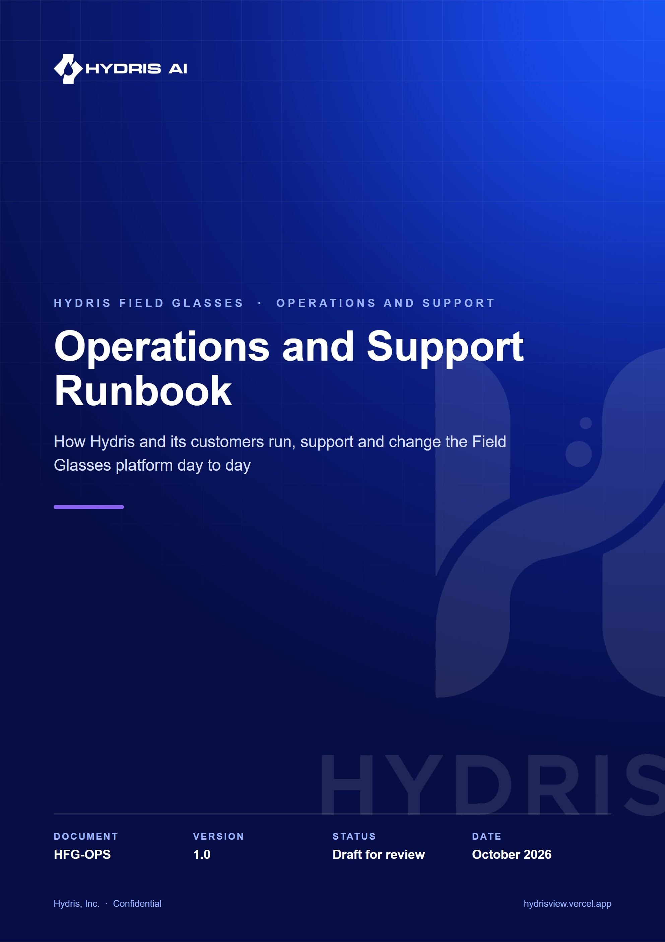
Document control
Document | Operations and Support Runbook (HFG-OPS)
Version | 1.0
Status | Draft for review
Owner | Customer success and operations, Hydris
Audience | Hydris support (L1, L2, L3), customer success, engineering on call, customer administrators and plant supervisors
Product | Hydris Field Glasses: website, operator console, glasses app, Android app, API
Source of truth | docs/product/OPERATIONS_RUNBOOK.md in tarun-km/hydrisview (this Word file is generated from it)
Classification | Confidential: Hydris, Inc. and named partners
Revision history
Version | Date | Author | Changes
1.0 | October 2026 | Customer success and operations, Hydris | First edition. Operating model, onboarding, fleet and audit operations, troubleshooting trees, incidents, releases, training and KPIs

Contents
1 Operating model 6
1.1 Platform surfaces 6
1.2 Roles 7
1.3 Support tiers and routing 7
1.4 RACI 8
2 Customer onboarding 10
2.1 End-to-end flow 11
2.2 Organisation creation 12
2.3 Sites, assets and sensors 12
2.4 Gateways and telemetry 13
2.5 Alarm rules 14
2.6 Users, roles and site scope 14
2.7 UI profiles for glasses 15
2.8 SOPs and inspection templates 15
2.9 Glasses procurement and phone setup 15
2.10 Pairing and training 15
2.11 Typical pilot rollout 16
3 Routine operations 17
3.1 Daily checklist 17
3.2 Weekly checklist 17
3.3 Monthly checklist 18
4 Glasses fleet management 19
4.1 Device lifecycle 19
4.2 Pairing 19
4.3 Reassigning a device 22
4.4 Suspending, revoking and logging out 22
4.5 Battery, charging and diagnostics 22
4.6 Firmware and the Meta AI app 22
4.7 Developer Mode 23
4.8 Phone setup procedure 23
5 Android app distribution and updates 25
6 Audit document operations 26
6.1 Pipeline and states 26
6.2 Review queue 27
6.3 Verification SLAs 27
6.4 Rejected scans 28
6.5 PDF archive 28
7 Alarm operations and escalation 29
7.1 Alarm lifecycle 29
7.2 Escalation matrix 30
7.3 Alarm hygiene 31
8 Support procedures and troubleshooting 32
8.1 Ticket intake 32
8.2 Cannot sign in 32
8.3 Pairing fails or code expired 34
8.4 Glasses not connecting (Ray-Ban Meta) 34
8.5 Camera not available 36
8.6 OCR results are poor 38
8.7 Voice assistant not hearing 40
8.8 Data not updating (telemetry stale) 43
8.9 Console slow 44
9 Incident management 45
9.1 Severity levels 45
9.2 Incident lifecycle 46
9.3 Communication templates 47
9.4 Postmortem template 47
10 Monitoring and health checks 48
10.1 Health endpoint 48
10.2 Scheduled jobs 48
10.3 Signals to watch 48
11 Data requests 50
11.1 Exports 50
11.2 Deletion and DPDP requests 50
12 Demo environment management 52
13 Release and change management 54
13.1 Environments and the path to production 54
13.2 Maintenance windows 54
13.3 Rollback 54
14 Training curriculum 55
14.1 Curriculum 55
14.2 Operator journey 55
15 Operations KPIs 57
16 Support contact and escalation templates 58
17 Appendices 59
17.1 Glossary 59
17.2 Command cheat sheet 59

This runbook is the working manual for everyone who keeps Hydris Field Glasses running for a customer: the Hydris support tiers, customer success, the engineer on call, and the customer's own administrators and plant supervisors. It covers onboarding a new plant, the routine checks that keep data and devices healthy, the procedures for glasses, audit documents and alarms, troubleshooting decision trees for the problems we see most, incident handling, releases, training and the operational KPIs.
Every procedure is grounded in the current code. Where a step depends on behaviour in the API, the console, the glasses web app or the Android app, the file is named so that support staff can confirm it and engineers can keep this document honest. Each capability carries a status:
- Built: present in the code on main and usable today.
- Partial: works, with a known gap that the procedure works around.
- Planned: not in the code yet. The procedure describes the intended practice or a manual stopgap.
All targets in this document (response times, SLAs, KPIs) are targets, not measured results. No production KPI data exists yet; the numbers are proposals for the first pilot and will be revised from pilot data.
IMPORTANT
Hydris is read-only to the plant. No endpoint writes to a PLC, SCADA or DCS. Acknowledging an alarm in Hydris records that a person has seen it; it never changes the physical process (packages/domain/src/alarms.ts). Every support conversation about an alarm must keep this distinction clear: the plant's own control system and procedures remain the authority.

1 Operating model

1.1 Platform surfaces
Support staff should be able to name which surface a user is on before troubleshooting, because the failure modes differ.
Table 1. Platform surfaces and where they live in the code
Surface | Users | Code | Notes
Operator console | Admins, managers, supervisors, viewers | apps/web/src/app/console | Overview, sites, assets, telemetry, map, alarms, inspections, maintenance, documents, audit documents, devices, glasses profiles, operators, reports, audit, settings, platform
Glasses web app | Operators on display glasses or the phone layout | apps/web/src/glasses, routes /glasses, /simulator, /pair | Device refresh token in localStorage (glasses/link.ts)
Hydris Field Android app | Operators with Ray-Ban Meta glasses | apps/android (ai.hydris.field, minSdk 31, DAT mwdat-core 1.0.1) | Connects to the glasses through the Meta AI app
API | All of the above, gateways | apps/api (Fastify, Postgres with RLS), served in-process on Vercel at /api | /api/health, daily cron /api/cron
Telemetry gateways | Plant edge | POST /api/ingest/v1/readings with an hgw_ key | Created in the console (POST /gateways)

The hosted deployment is https://hydrisview.vercel.app (vercel.json, framework Next.js). The Android app points there by default through hydris_url in apps/android/local.properties (apps/android/app/build.gradle.kts).

1.2 Roles
Hydris operations uses five human roles. Two sit with the customer and map to roles in the product (packages/domain/src/roles.ts); three sit with Hydris.
Table 2. Operating roles and what each one owns
Role | Organisation | Product role | Owns
Hydris support L1 | Hydris customer success | None in the tenant | First response, triage, known-issue fixes, guided procedures, ticket hygiene
Hydris support L2 | Hydris operations | Platform admin when needed (req.platformUserId, apps/api/src/modules/org.ts) | Tenant configuration, device and account recovery, data exports, cron and health checks, Vercel logs
Hydris support L3 | Hydris engineering on call | Platform admin, database access | Code defects, database operations, secret rotation, restores, releases and rollbacks
Customer admin | Customer | org_admin (all permissions) or factory_manager | Users and roles, sites, assets, sensors, gateways, UI profiles, SOPs, device fleet
Plant supervisor | Customer | supervisor | Daily alarm handling, inspection review, audit document verification, pairing approvals

Product roles and their permissions are fixed in code. Field operators (field_operator) and maintenance engineers (maintenance_engineer) are the glasses wearers; viewers (viewer) read only. A factory manager can assign only supervisor, field_operator, maintenance_engineer and viewer; only an org admin can create another org admin (assignableRoles). Everyone except the org admin is limited to the sites on their membership by default (SITE_SCOPED_BY_DEFAULT).

1.3 Support tiers and routing
L1 handles anything that a documented procedure in this runbook resolves. L2 handles anything that needs configuration access, logs or a platform-admin action. L3 handles code, data and infrastructure. The customer admin is always the first line inside the plant: operators go to their supervisor, the supervisor to the customer admin, the customer admin to Hydris.
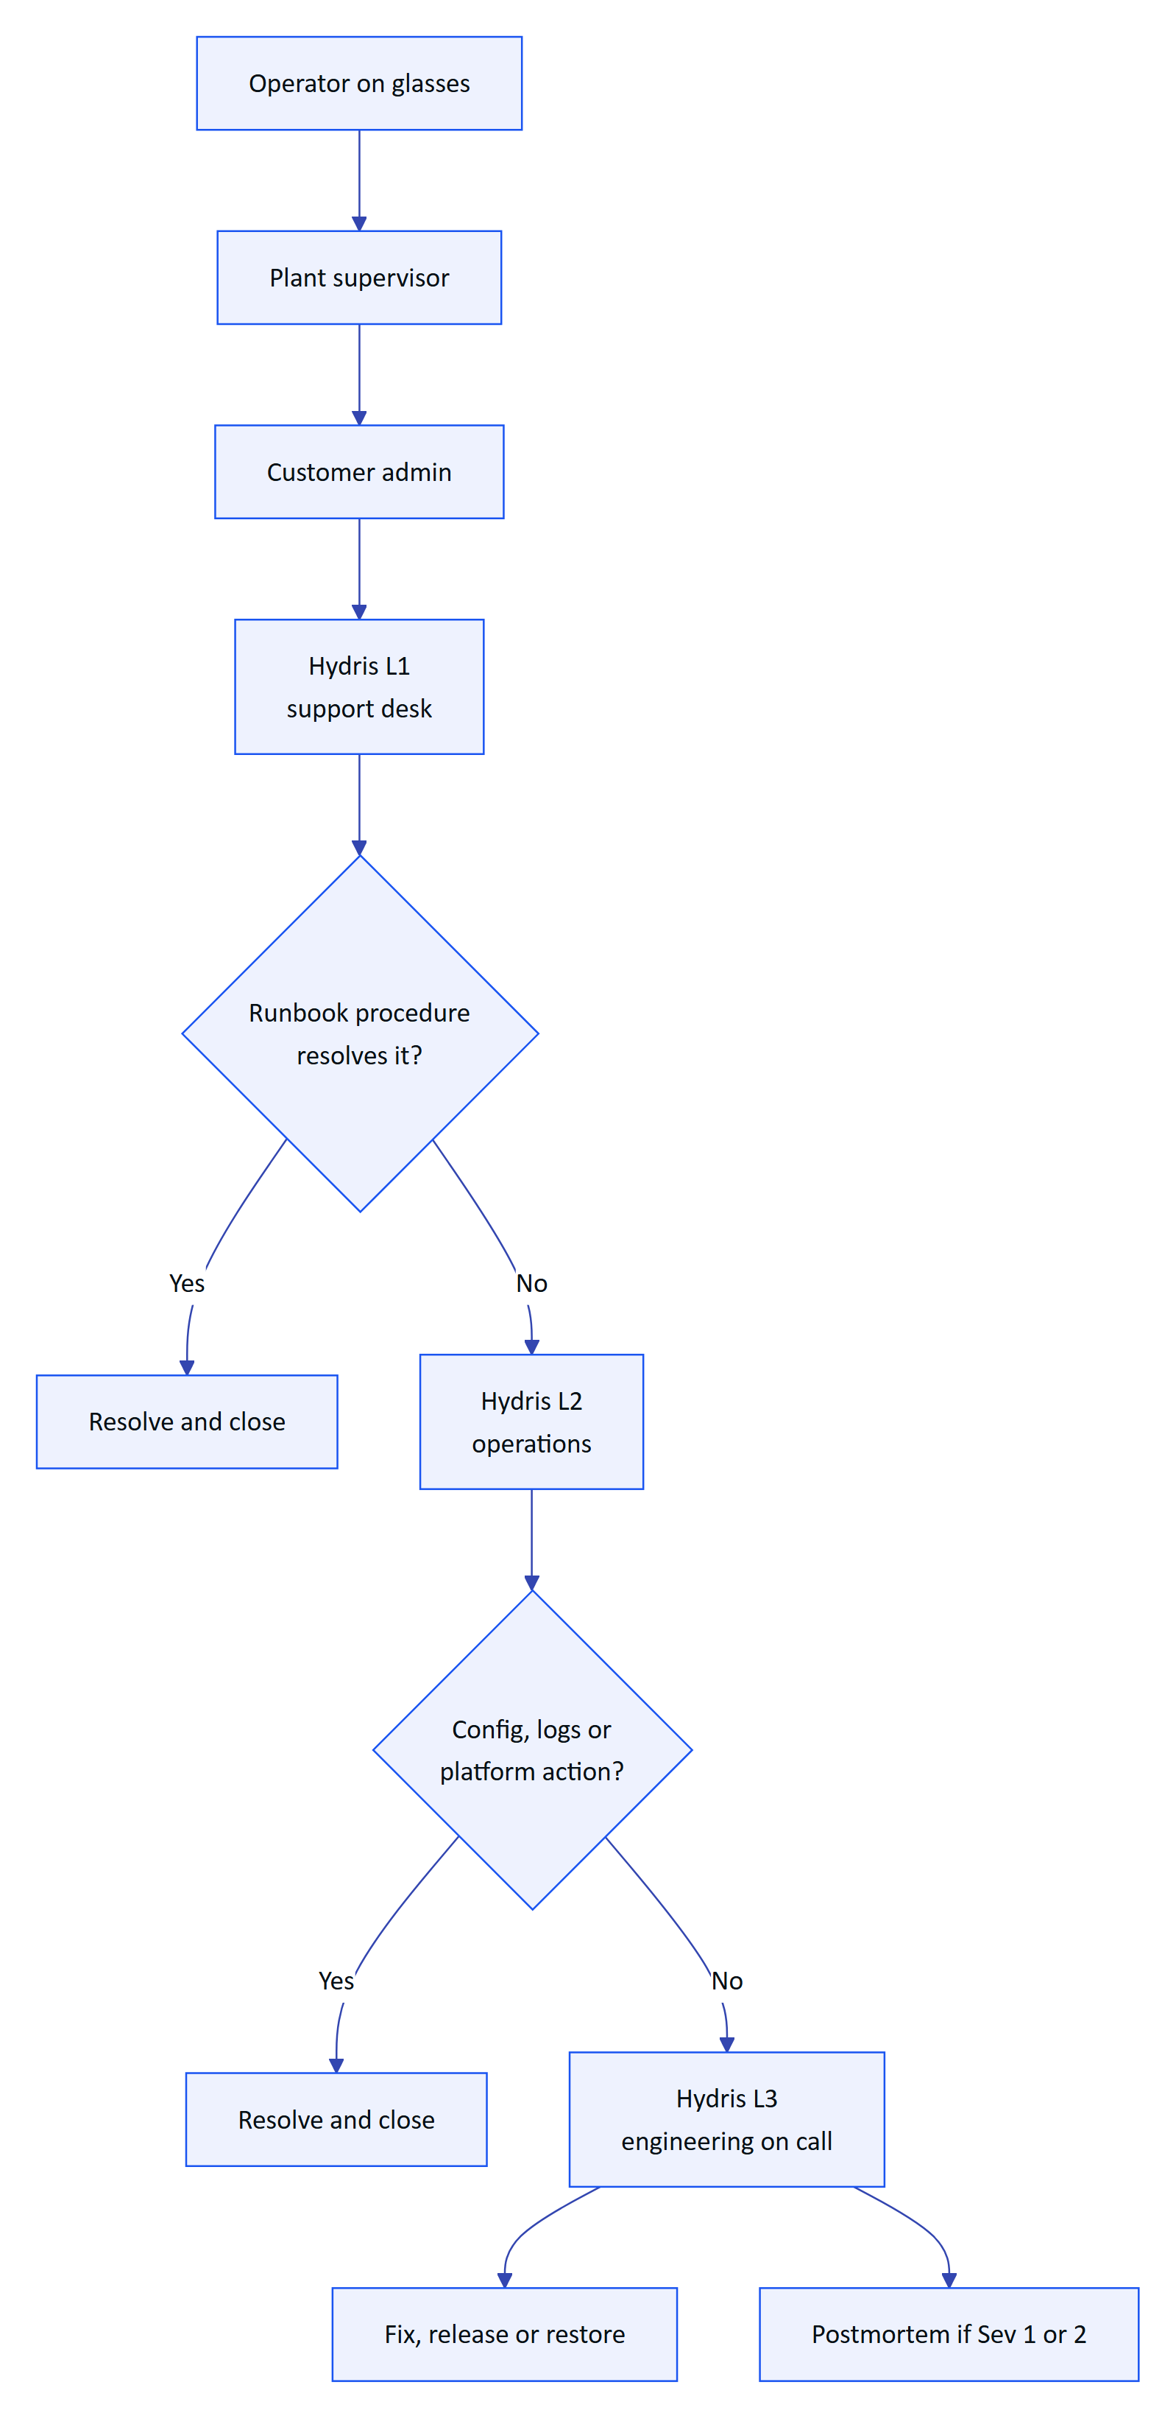
Figure 1. Support routing from the operator to Hydris engineering

1.4 RACI
R is responsible (does the work), A is accountable (one per row), C is consulted, I is informed.
Table 3. RACI for recurring operational activities
Activity | L1 | L2 | L3 | Customer admin | Plant supervisor
Create organisation and first admin | I | A, R | C | I
Sites, assets, sensors, gateways | C | C |  | A, R | C
Users, roles and site scope | C |  |  | A, R | C
UI profiles for glasses | C | C |  | A, R | C
SOP and document upload |  |  |  | A | R
Glasses procurement and setup | C | R |  | A | C
Pairing approval | C |  |  | A | R
Lost or stolen device revocation | C | R |  | A | R
Alarm acknowledgement and resolution |  |  |  | A | R
Audit document verification and approval |  |  |  | A | R
Telemetry ingestion health | I | R | C | A | I
Daily health check and cron report |  | A, R | C
Sev 1 and Sev 2 incidents | R | R | A | C | I
Release and rollback | I | C | A, R | I
Data export, deletion and DPDP requests | R | R | C | A
Training delivery | C | R |  | A | R

2 Customer onboarding
Onboarding takes a customer from a signed pilot to operators using glasses on shift. The order matters: devices cannot be paired to a site that does not exist, and pairing approval needs a member with device.pair on that site.

2.1 End-to-end flow
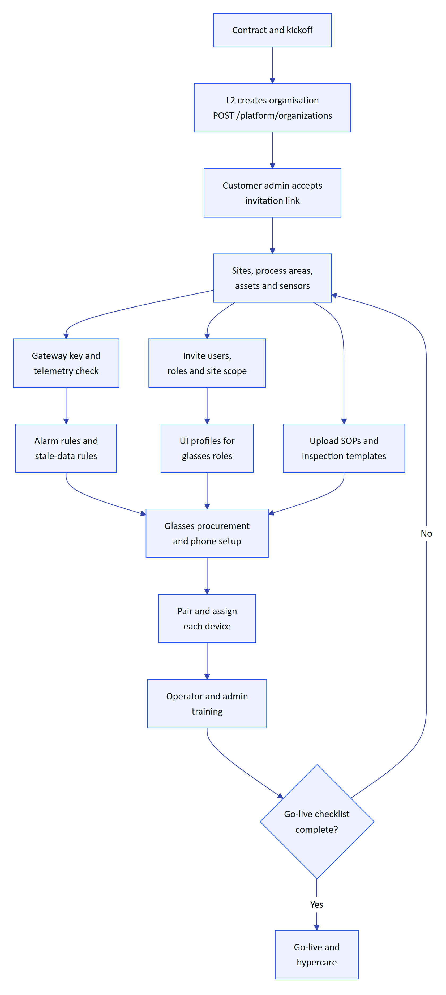
Figure 2. Customer onboarding from organisation creation to go-live

2.2 Organisation creation
Built. A platform admin creates the tenant with POST /api/platform/organizations (apps/api/src/modules/org.ts). The response carries adminInvitationLink, an invitation for the first org_admin with access to all sites. The same action is available in the console under Platform (apps/web/src/app/console/platform).
- L2 confirms the legal entity name, the plant list and the first admin's name and email.
- L2 signs in to the console as a platform admin and creates the organisation.
- L2 sends the invitation link to the customer admin over the agreed channel. The link is valid for 7 days (TTL.inviteMs in apps/api/src/config.ts).
- The customer admin opens the link (/invite/<token>), sets a password and signs in.
WARNING
Email delivery is Partial. sendMail in apps/api/src/core/services.ts writes to the mail_outbox table; there is no outbound mail transport yet. Invitation links are returned to the inviter in the API response so they can be shared by hand. Password-reset links are written only to mail_outbox, so a user who forgets a password needs L2 help (see the sign-in troubleshooting tree). Treat mail_outbox rows as sensitive.

The first platform admin for a new environment is created with the seed script, which also applies migrations:
SEED_ADMIN_EMAIL=ops@hydris.ai SEED_ADMIN_PASSWORD='<12+ characters>' npm run seed

2.3 Sites, assets and sensors
Built. The customer admin (or a factory manager) builds the plant hierarchy in the console under Sites and Assets: site, facility, process area, asset, sensor (apps/api/src/modules/plant.ts). Points to check with the customer:
- Each sensor's expected interval is realistic. Freshness is derived from it: live within 2 times the interval, delayed within 5 times, stale beyond that (packages/domain/src/freshness.ts). An interval that is too short makes healthy sensors show as stale.
- Lab and manual parameters get long intervals (hours or days) and are entered with manual telemetry (POST /api/telemetry/manual).
- Asset tags match the tags on the plant floor and on the SOPs, because operators ask the voice assistant by tag.
- Process area polygons are drawn on the Map so the glasses map and console map agree.
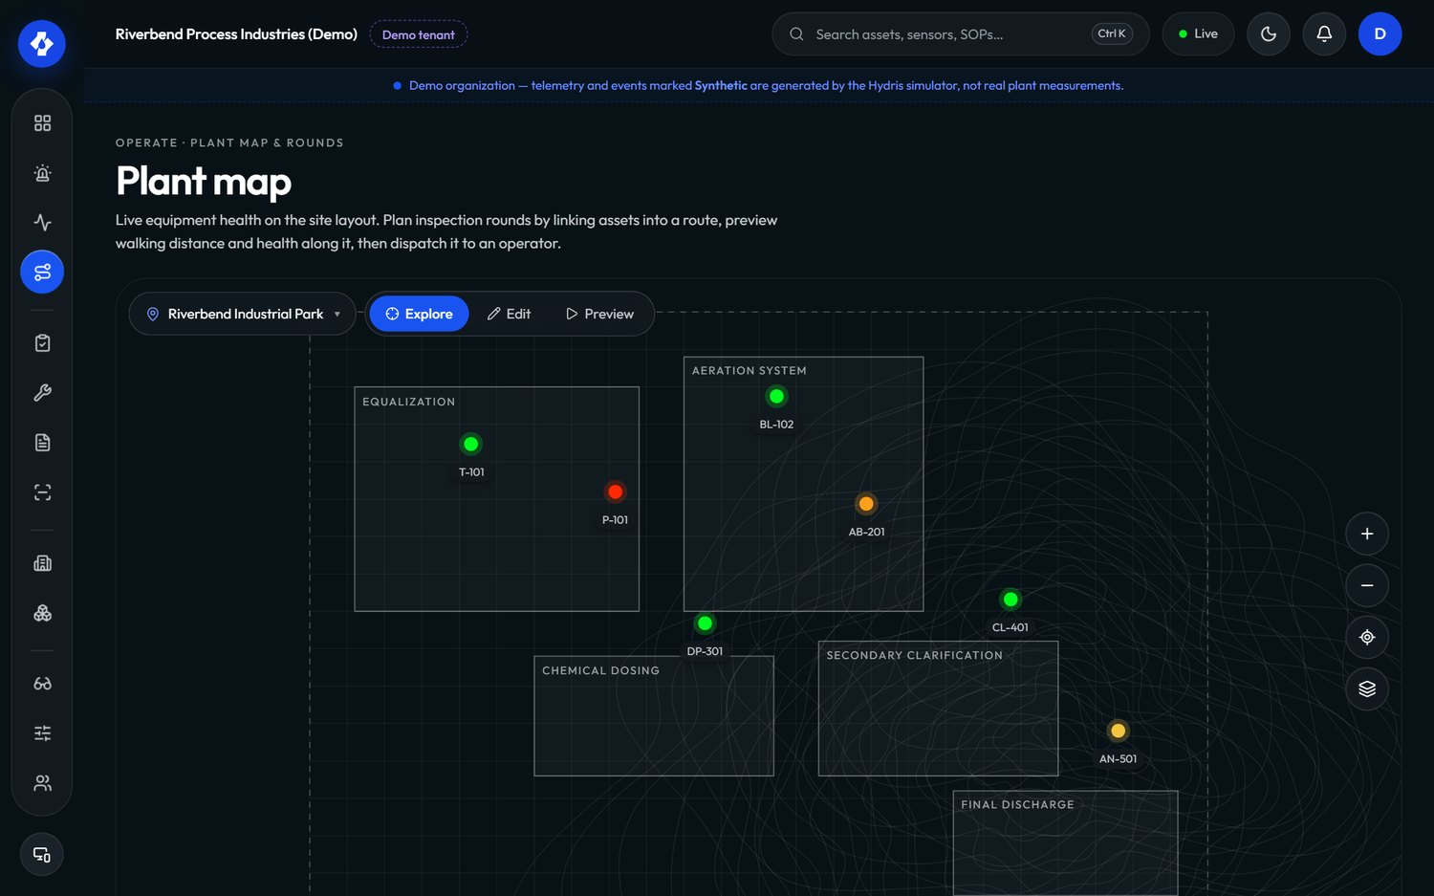
Figure 3. Console map with sites and process areas

2.4 Gateways and telemetry
Built. For live data, the customer admin creates a gateway in the console (POST /api/gateways, protocol https, mqtt or opcua). The key starts with hgw_ and is shown once; only its hash is stored. The gateway posts batches of up to 500 readings to POST /api/ingest/v1/readings with Authorization: Bearer hgw_.... The route is rate limited to 1,200 requests a minute per client (apps/api/src/modules/telemetry.ts).
Before go-live, L2 confirms on the Telemetry page that every sensor shows Live, and that a deliberately paused sensor turns Delayed then Stale at the expected times.
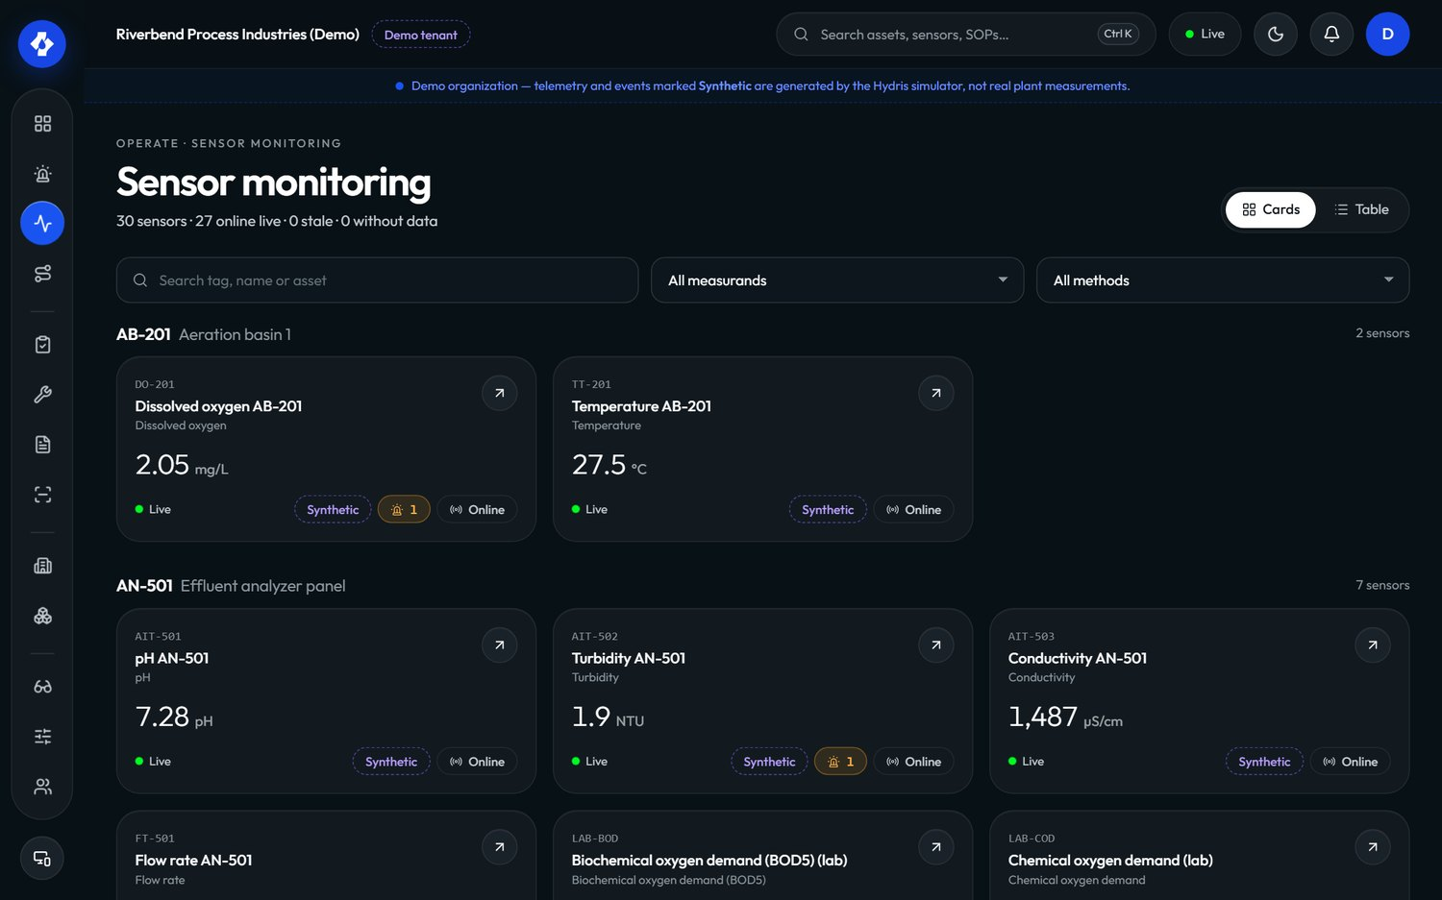
Figure 4. Console telemetry view with freshness states
For a pilot without a live gateway, the simulator (/simulator, apps/api/src/modules/simulation.ts) drives synthetic scenarios such as pump_vibration, tank_high_level, abnormal_ph and equipment_offline (packages/domain/src/scenarios.ts). Simulated readings are flagged as synthetic in the database and must never be mixed into a customer's compliance reporting.

2.5 Alarm rules
Built. Threshold rules (high_high, high, low, low_low) with a deadband, and stale rules that raise No fresh data when a sensor stops reporting (apps/api/src/modules/alarms.ts). The customer's process engineer owns the thresholds; Hydris only helps enter them. Every critical sensor should have a stale rule, because a silent sensor is more dangerous than a noisy one.

2.6 Users, roles and site scope
Built. Under Operators, the customer admin invites each person with a role, a title and the sites they cover (POST /api/invitations). Members can later be deactivated (PATCH /api/members/:userId with status: deactivated), and nobody can change their own role or status.
Table 4. Recommended role mapping for a typical effluent treatment plant
Plant job | Product role | Typical surface
Plant head, EHS head | factory_manager | Console
Shift in-charge | supervisor | Console and phone
ETP operator | field_operator | Glasses
Maintenance fitter or electrician | maintenance_engineer | Glasses
Auditor, corporate EHS, consultant | viewer | Console
Customer IT or digital lead | org_admin | Console

Encourage admins and managers to enable two-step verification (TOTP, POST /api/auth/mfa/setup). Note the Android limitation in the sign-in troubleshooting tree.

2.7 UI profiles for glasses
Built. A UI profile controls which screens and actions the glasses show (apps/api/src/modules/ui-profiles.ts, packages/domain/src/uiprofile.ts). Profiles are edited as drafts, published as numbered versions and can be rolled back. Assignment precedence is most specific first: device, then user, then role, then org, then the built-in default. Configure them under Glasses profiles in the console.
Recommended starting set: one profile per glasses role (field_operator, maintenance_engineer), assigned by role. Use device-level assignments only for exceptions, because they are easy to forget when a device changes hands.

2.8 SOPs and inspection templates
Built. SOPs, method statements and other references are uploaded under Documents (POST /api/documents, permission document.manage) and linked to a site or asset. Only approved documents appear in search results on the glasses (apps/api/src/modules/insights.ts). Inspection templates and routes are built under Inspections and dispatched to operators (POST /api/inspection-routes/:id/dispatch). Attachments are limited to 10 MB per file (apps/api/src/app.ts).

2.9 Glasses procurement and phone setup
Two glasses paths are supported:
Table 5. Glasses paths and what each needs
Path | Hardware | Software | Status
Ray-Ban Meta | Ray-Ban Meta glasses plus an Android 12 or later phone per operator | Meta AI app (pairs glasses, grants permissions, updates firmware) and Hydris Field (apps/android) | Built for camera, capture button and voice through DAT. Distribution needs Developer Mode until Meta approves the app
Display glasses or phone | Android display glasses with a browser, or a phone | Browser at /glasses | Built

Per operator for the Ray-Ban Meta path, L2 prepares a kit: glasses, charging case, a dedicated Android phone, a protective case and a lanyard. The setup procedure is in the fleet chapter.

2.10 Pairing and training
Each device is paired to a site and assigned to an operator (see the fleet chapter). Training follows the curriculum in the training chapter. Go-live happens when every item below is ticked.
- ☐ Every sensor shows Live or has a documented reason
- ☐ Stale rules exist on every critical sensor
- ☐ Every operator has an account, the right role and the right sites
- ☐ UI profiles published and assigned by role
- ☐ SOPs for the pilot assets uploaded and approved
- ☐ Every device paired, named after its holder or station, and assigned
- ☐ A test audit document scanned, verified and approved by two different people
- ☐ A test alarm raised, acknowledged, resolved with a note and closed
- ☐ Supervisors and the customer admin trained and signed off
- ☐ Escalation contacts exchanged and the support channel tested

2.11 Typical pilot rollout
The plan below is a plan, not a commitment: a six-week pilot for one plant with up to ten operators.
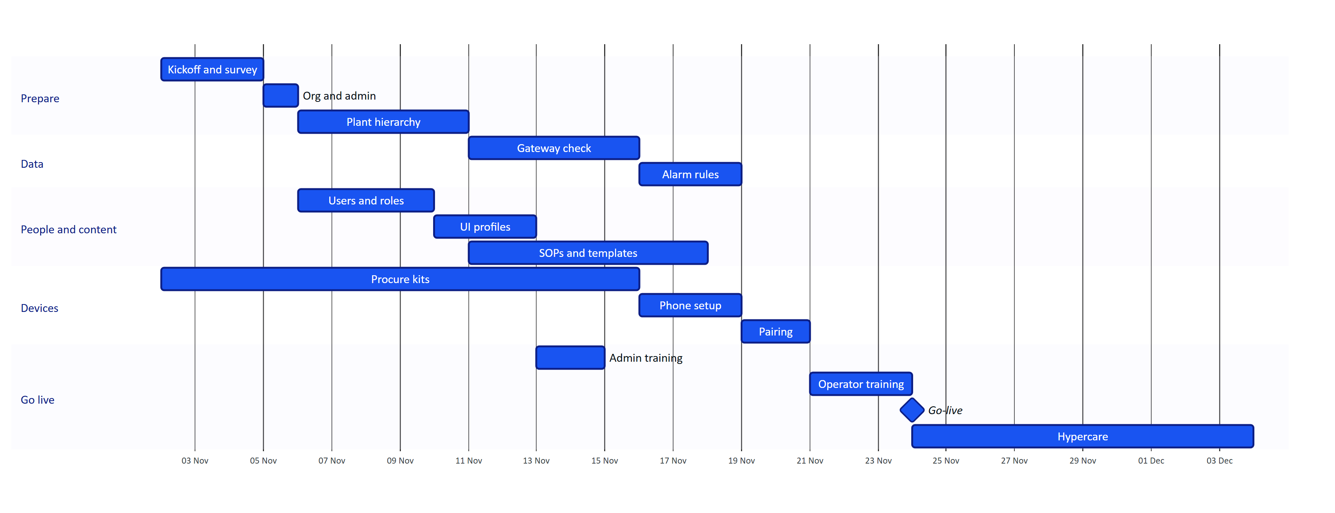
Figure 5. Typical six-week pilot rollout (plan)

3 Routine operations

3.1 Daily checklist
Owner shown in brackets. Hydris tasks assume one hosted deployment; repeat per deployment.
- ☐ (L2) GET /api/health returns {"ok":true,...} from the production domain
- ☐ (L2) Vercel Cron Jobs shows the last /api/cron run with ok: true, and every field in report is ok or a number (staleRules, pairingExpiry, realtimePruned, simulationSteps)
- ☐ (L2) Vercel function logs: no new spike of 5xx responses, 503 API is starting or misconfigured, or realtime_misconfigured
- ☐ (L2) No unexpected auth.refresh_reuse_detected or device.refresh_reuse_detected events in the audit log
- ☐ (Supervisor) Console Overview: no open critical or high alarm older than its target, no sensor stale without a known reason
- ☐ (Supervisor) Audit documents: review queue within the verification SLA
- ☐ (Supervisor) Devices: every glasses device on shift is Connected; anything Disconnected is explained
- ☐ (Operator) Glasses charged, phone charged, Hydris Field signed in, wake phrase tested once at shift start
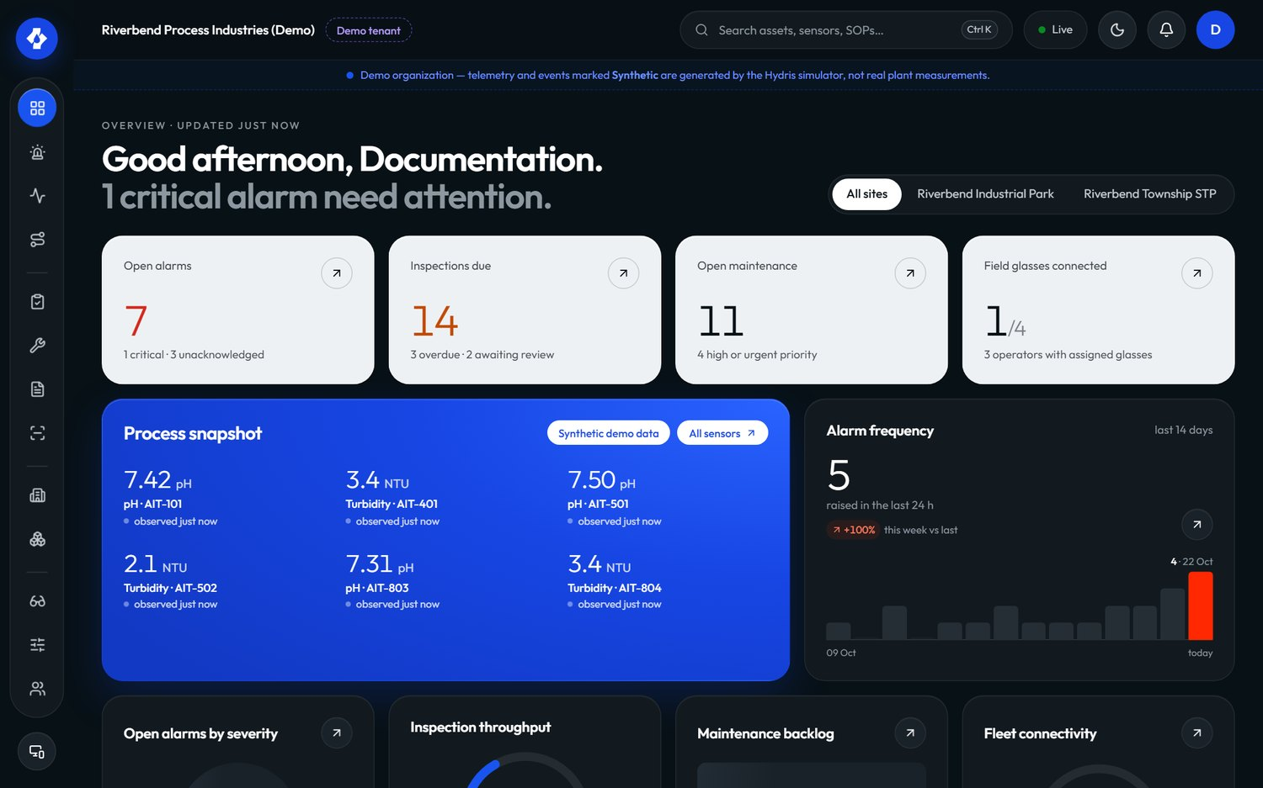
Figure 6. Console overview used for the daily check

3.2 Weekly checklist
- ☐ (Customer admin) Review Operators: leavers deactivated, role changes applied, site scope correct
- ☐ (Customer admin) Review Devices: suspended devices either reactivated or revoked, assignments match the shift roster
- ☐ (Supervisor) Export the alarm report (GET /api/reports/alarms?format=csv) and review repeat offenders and long acknowledgement times
- ☐ (Supervisor) Rejected audit documents rescanned or closed out
- ☐ (L2) Review open tickets older than 5 business days and escalate
- ☐ (L2) Check Meta AI app and DAT release notes for changes that affect pairing or permissions
- ☐ (L2) Confirm the cron schedule still matches the plan (see monitoring chapter)

3.3 Monthly checklist
- ☐ (Customer admin) Access review: every org_admin and factory_manager still needs that role; MFA enabled for them
- ☐ (Customer admin) UI profile review: drafts published or discarded, no stale device-level overrides
- ☐ (Customer admin) SOP review: superseded documents archived, new revisions approved
- ☐ (L2) Device report (GET /api/reports/devices?format=csv): devices not seen for 30 days investigated
- ☐ (L2) KPI pack for the customer (operations KPIs chapter)
- ☐ (L3) Dependency and security advisories reviewed; release planned if needed
- ☐ (L3) Restore drill on staging once a quarter (DEPLOYMENT.md backup targets: RPO 15 minutes, RTO 4 hours, both targets)

4 Glasses fleet management

4.1 Device lifecycle
A device record is active, suspended or revoked. The console shows a derived state (deriveDeviceState in packages/domain/src/devices.ts): a device counts as Connected if it has an open realtime stream or was seen in the last 90 seconds.
Table 6. Device states shown in the console and what support should do
State | Meaning | Support action
Pending pairing | Challenge created, not yet approved | Approve within 5 minutes or generate a new code
Paired | Paired, no operator assigned | Assign an operator; the glasses cannot refresh tokens without one
Assigned | Assigned, never seen | Ask the operator to open the app and sign in on the glasses
Connected | Seen in the last 90 s | None
Disconnected | Assigned, seen before, not in the last 90 s | Check battery, phone, network
Suspended | Temporarily blocked | Reactivate when the reason is cleared
Revoked | Permanently blocked; sessions ended | Pair again as a new device if the hardware is recovered

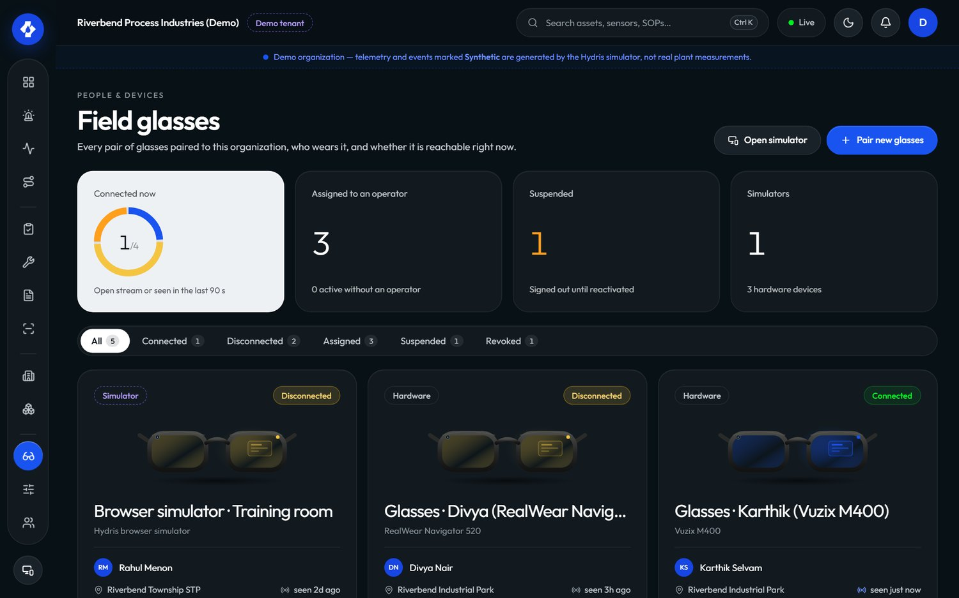
Figure 7. Console devices page

4.2 Pairing
Built. Pairing follows the shape of the OAuth 2.0 device authorization grant (apps/api/src/modules/devices.ts, packages/domain/src/devices.ts):
- The glasses request a challenge and show an 8-character code as XXXX-XXXX plus a QR code. The alphabet excludes easily confused characters (no 0, O, 1, I, L, U).
- The code lives for 300 seconds (PAIRING_TTL_S). The glasses poll every 3 seconds; faster polling receives slow_down.
- The QR encodes only PUBLIC_APP_URL/pair?code=XXXX-XXXX, never a credential.
- An authenticated person with device.pair approves the code, picks the site and optionally the operator and a device name.
- Code lookups are rate limited (PAIRING_MAX_LOOKUPS_PER_MINUTE is 10).
- The glasses then receive a device access token (15 minutes, 12 hours in demo mode) and a device refresh token (30 days, TTL.deviceRefreshMs).
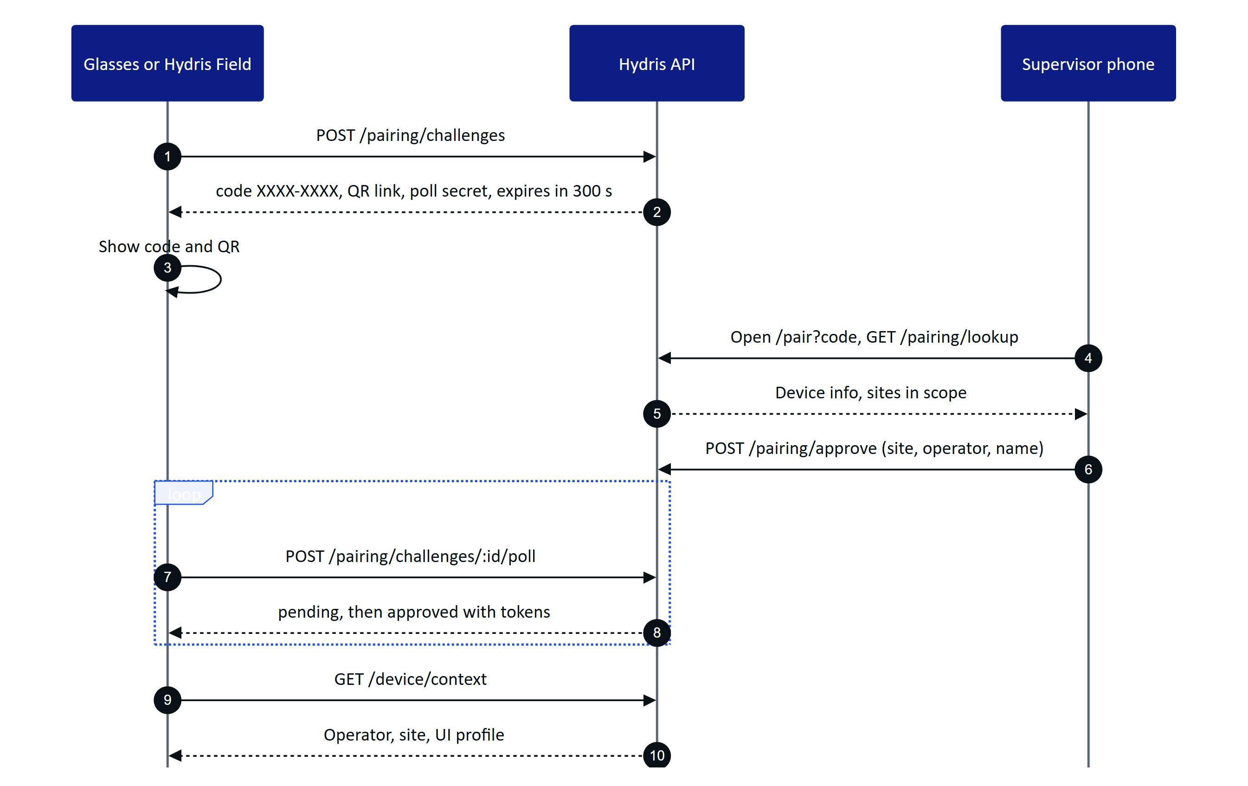
Figure 8. Pairing a glasses device with a supervisor approving on a phone
On the Ray-Ban Meta path, pairing happens from the Glasses tab in Hydris Field ("Register as Hydris device"). On display glasses, the /glasses route shows the code; /simulator does the same in a desktop browser for demos.
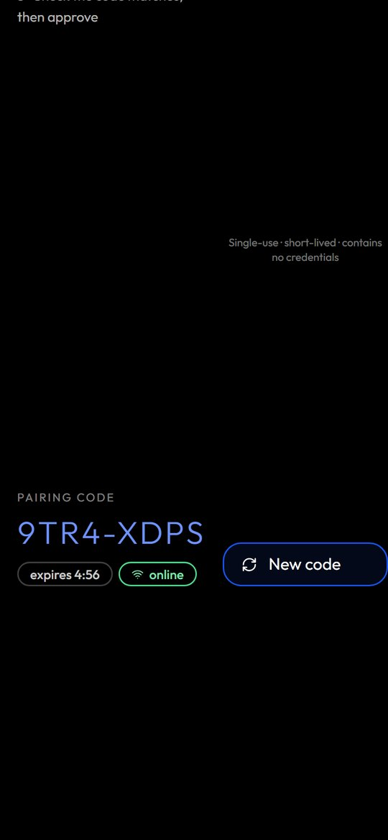
Figure 9. Phone layout of the glasses web app showing a pairing code

4.3 Reassigning a device
Built. Under Devices, open the device and choose a new operator (POST /api/devices/:id/assign). Only active devices can be reassigned. Reassignment closes the previous assignment, records the reason, invalidates outstanding device tokens and pushes a device.context_changed event so the glasses reload the new operator's work. The operator does not need to re-pair.
Use reassignment for shift handovers of shared glasses. Use revocation only when the hardware is lost or leaves the organisation.

4.4 Suspending, revoking and logging out
Built.
- Suspend (POST /api/devices/:id/suspend): blocks the device immediately. Use when a device is temporarily missing or an operator is on leave. Reactivate with POST /api/devices/:id/reactivate.
- Revoke (POST /api/devices/:id/revoke, reason required): final. Ends every device session, releases the assignment and invalidates tokens. A revoked device must be paired again as a new device. Glasses owned by another organisation cannot be paired until revoked there.
- Logout or unpair from the glasses (POST /api/device/logout): the wearer ends the device's own sessions so it can be paired again by anyone. Use when moving a device between people without console access.
Lost or stolen device procedure:
- The operator tells the supervisor immediately.
- The supervisor or customer admin suspends the device in the console within 15 minutes (target).
- If it is not found by the end of the shift, the customer admin revokes it with the reason "lost" or "stolen".
- If the device was a Ray-Ban Meta pair, the customer also removes the glasses from the Meta AI app account and, for a stolen phone, uses their mobile device management to wipe it.
- L1 records the ticket; L2 confirms in the device detail that active sessions is empty.

4.5 Battery, charging and diagnostics
Partial. The device detail page shows last seen time, last IP, app version, firmware version and display info. Battery level is not available: the API returns battery: null with the note that battery and hardware sensors are not exposed by the current device integration (GET /api/devices/:id). Operational rules until it is:
- Glasses go back in the charging case at every break. The phone charges on a shift-start dock.
- Supervisors check the case LED at handover.
- Continuous voice listening and camera streaming drain both glasses and phone; operators turn listening off when not needed.

4.6 Firmware and the Meta AI app
Glasses firmware and DAT permissions are owned by Meta's tooling, not by Hydris. The Meta AI app must stay installed and signed in on every operator phone: it pairs the glasses, registers Hydris as a permitted integration, grants camera access and delivers firmware updates (GLASSES_INTEGRATION.md). The Meta AI app and glasses firmware must meet the DAT version dependencies.
Firmware procedure (L2, monthly or when Meta releases):
- Test the new firmware on one spare kit with the current Hydris Field build: connect, capture, voice.
- If it passes, ask the customer admin to update the fleet in the Meta AI app between shifts.
- Record the firmware version from the device detail page after the update.

4.7 Developer Mode
Partial. Until Hydris Field is approved in the Meta Wearables Developer Center, DAT features work only with Developer Mode enabled in the Meta AI app, using the development identifiers (mwdat_application_id and mwdat_client_token both 0 in apps/android/local.properties). Production builds need the identifiers issued by Meta. Enable Developer Mode on each phone in the Meta AI app settings during phone setup, and re-check it after any Meta AI app update.
RISK
Developer Mode is a per-phone setting outside Hydris control. A Meta AI app update or a phone reset can turn it off, and the glasses then stop connecting with no change on the Hydris side. Put "Developer Mode on" at the top of every glasses troubleshooting call.

4.8 Phone setup procedure
Per operator phone (L2 or customer admin):
- Android 12 or later (minSdk 31). Update the OS.
- Install the Meta AI app, sign in with the customer's Meta account, pair the glasses, update firmware, enable Developer Mode.
- Install Hydris Field (see distribution below).
- Open Hydris Field and sign in with the operator's Hydris account.
- Glasses tab: connect Hydris in the Meta AI app, approve camera and microphone, then "Register as Hydris device" and have a supervisor approve the code.
- Test: guided capture of one page, "Hey Hydris, what alarms are open?".
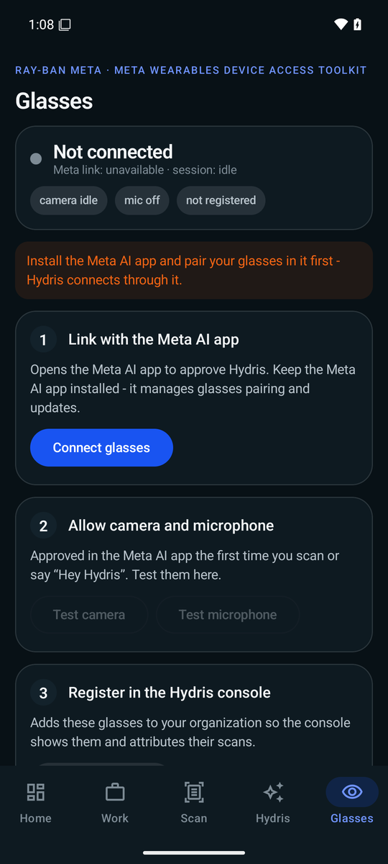
Figure 10. Hydris Field glasses tab

5 Android app distribution and updates
Partial. The app is ai.hydris.field, versionName 1.0.0, versionCode 1 (apps/android/app/build.gradle.kts). There is no CI pipeline in the repository yet, so builds are produced by hand.
Table 7. Android distribution channels
Channel | When | Status
Debug or release APK installed with adb | Internal testing, first pilot | Built (manual)
Google Play internal testing (up to 100 testers) | Pilots | Planned
Meta Wearables Developer Center release channel | DAT features for non-developers | Planned
Managed Google Play through the customer's MDM | Enterprise rollout | Planned

Update procedure for the pilot (L3 builds, L2 distributes):
- L3 bumps versionCode and versionName, builds the release APK and records the commit.
- L2 installs it on the spare kit and runs the smoke test: sign in, connect glasses, capture, voice, pairing.
- L2 installs it on the fleet between shifts. The device detail page shows the new app version once the phone checks in.
- Keep the previous APK so a phone can be downgraded if the new build fails (uninstall, then install the old APK; the operator signs in and the device is reassigned if needed).
cd apps/android
./gradlew assembleDebug
adb install -r app/build/outputs/apk/debug/app-debug.apk

6 Audit document operations

6.1 Pipeline and states
Built. Operators capture paper records (log sheets, lab reports, calibration certificates) with guided capture on the glasses or phone. Two independent OCR readings are taken on the device (the original image and a contrast-normalised copy, apps/android/app/src/main/java/ai/hydris/field/scan/OcrEngine.kt). The server structures key and value fields, tables and figures, optionally refined by a vision model when ANTHROPIC_API_KEY is set (GET /api/audit-docs/capabilities reports whether vision is on). Each value is cross-checked between engines, then reviewed by a person, verified, and independently approved (apps/api/src/modules/audit-docs.ts).
Limits: up to 6 pages per document, each page under 900 KB, request body 8 MB.
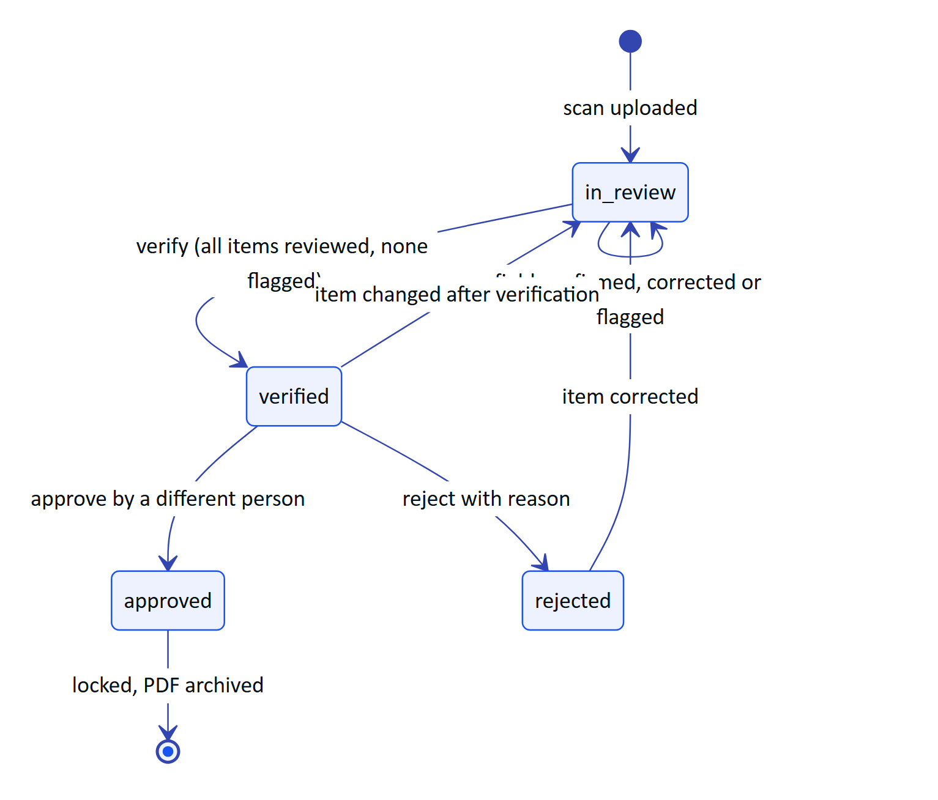
Figure 11. Audit document states and the two-person rule
Rules enforced in code:
- Verify needs auditdoc.verify and a signed-in user (not a device). Every item must be reviewed and no item may be flagged.
- Approve or reject needs auditdoc.approve. The approver must be a different person from the verifier, except in demo tenants where self-approval is allowed and recorded as such.
- Reject needs a reason.
- Any change after verification re-opens the review and clears the verifier and approver.
- Approved documents are locked: no edits, no renames.
- Corrections keep the extracted value (extracted); history is never overwritten.
Only org_admin and factory_manager hold auditdoc.approve. Supervisors can verify but not approve. Plan the approver roster accordingly: every site needs at least two people who can complete the chain.

6.2 Review queue
The console Audit documents page lists documents by status (GET /api/audit-docs?status=in_review). Items flagged as needing attention are those where the engines disagree (mismatch) or confidence is below 0.75 (needsAttention). Reviewers can bulk-confirm items where both engines agree and confidence is at least 0.8 (POST /api/audit-docs/:id/confirm-agreed), then work through the rest by hand.
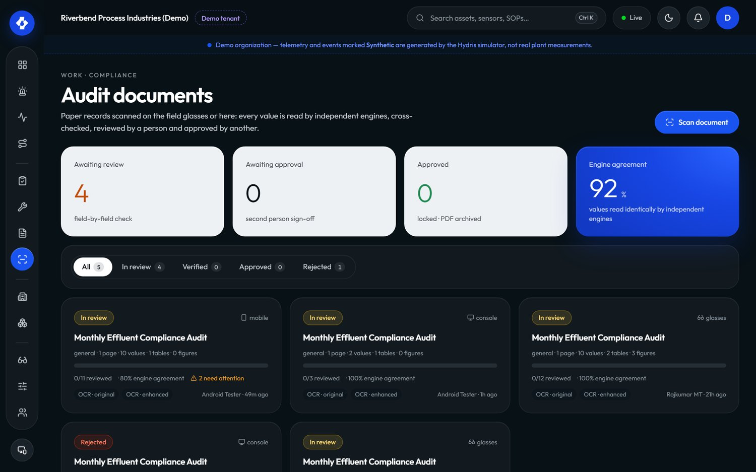
Figure 12. Console audit documents review

6.3 Verification SLAs
Table 8. Audit document turnaround targets (targets, not measured)
Step | Owner | Target
Scan to first review action | Supervisor | Same shift
Scan to verified | Supervisor | 1 business day
Verified to approved or rejected | Factory manager or org admin | 2 business days
Rejected to rescanned or closed | Supervisor and operator | 3 business days
Compliance-critical record (discharge, consent condition) scan to approved | Customer admin | 1 business day

6.4 Rejected scans
When a document is rejected, the reason is stored in rejectedReason. The supervisor decides between:
- Correct in place: if the problem is a misread value, correct the item; the document returns to review and goes through verify and approve again.
- Rescan: if the image is unusable (cut off, blurred, glare), the operator scans the paper again. The rejected record stays as evidence; reference it in the new document title.

6.5 PDF archive
Built. GET /api/audit-docs/:id/pdf produces a PDF with the page images, the extracted values and the verification trail (who captured, verified, approved, when, and the engines used; apps/api/src/core/audit-pdf.ts). Archive procedure (customer admin, weekly): download PDFs for approved documents and store them in the customer's document management system per their retention policy. A retention configuration inside Hydris is Planned.

7 Alarm operations and escalation

7.1 Alarm lifecycle
Built. Alarms have severity critical, high, medium or low and condition high_high, high, low, low_low or stale (packages/domain/src/alarms.ts). Transitions are permission-checked in the API, and resolution requires a note.
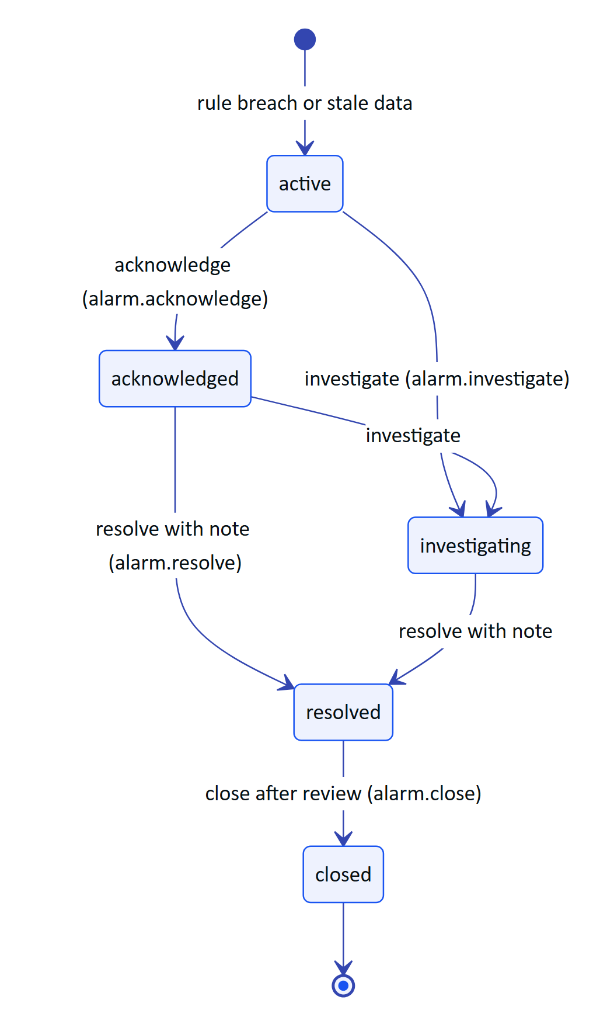
Figure 13. Alarm states and the permission each transition needs
Field operators can only acknowledge. Maintenance engineers can acknowledge, investigate and resolve. Supervisors and above can do everything including assignment (POST /api/alarms/:id/assign) and closing. Notes are added with POST /api/alarms/:id/notes. If two people act at once, the second gets stale_state and must refresh.
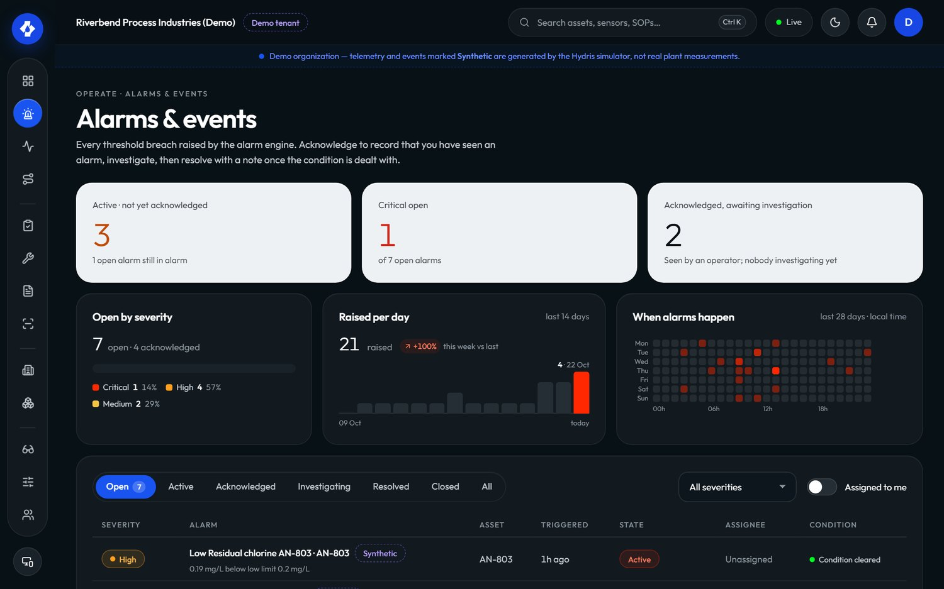
Figure 14. Console alarms page

7.2 Escalation matrix
Hydris does not page anyone outside the product yet: escalation beyond the console and glasses notifications is a customer procedure (Planned: SMS or call escalation). The matrix below is the recommended plant procedure; all times are targets.
Table 9. Alarm escalation matrix (targets)
Severity | Acknowledge within | First escalation | Second escalation | Resolve or hand to plant procedure within
Critical | 5 minutes | Supervisor at 5 minutes, by phone | Plant head at 15 minutes | 1 hour
High | 15 minutes | Supervisor at 15 minutes | Plant head at 1 hour | 4 hours
Medium | 1 hour | Supervisor at end of shift | None | 1 business day
Low | End of shift | None | None | 1 week
Stale (no fresh data) | 30 minutes | Customer admin (data path) | Hydris L1 if gateway or platform suspected | 4 hours

A stale alarm is a data problem first: follow the "data not updating" tree before assuming a plant fault, but never assume the plant is fine because the data stopped.

7.3 Alarm hygiene
Weekly, the supervisor reviews the alarm report for: alarms resolved without a meaningful note, repeat alarms on the same sensor (threshold or deadband needs tuning), and alarms closed by the same person who resolved them without review. Rule changes go through the customer's management of change; alarm_rule.manage is held only by org_admin and factory_manager.

8 Support procedures and troubleshooting

8.1 Ticket intake
L1 records for every ticket: customer, site, user email, role, surface (console, glasses web app, Hydris Field), device name, app version, time of the problem with time zone, and what the user saw (exact message or screenshot). Never ask for or record passwords, MFA codes, refresh tokens, gateway keys or CRON_SECRET.
Table 10. Support response targets by priority (targets)
Priority | Example | First response | Update cadence | Target resolution
P1 | Nobody can sign in; all telemetry stale | 30 minutes | Hourly | 4 hours
P2 | One site cannot pair glasses; audit approval blocked | 2 hours | Every 4 hours | 1 business day
P3 | One operator's voice not working | 1 business day | Daily | 3 business days
P4 | Question, how-to, feature request | 2 business days | Weekly | Best effort

8.2 Cannot sign in
Facts from the code (apps/api/src/modules/auth.ts, apps/api/src/config.ts): wrong email or password returns invalid_credentials. Five failures lock the account for 15 minutes (account_locked). Access tokens last 15 minutes and refresh tokens 7 days; reuse of a rotated refresh token revokes the family. On the Android app, an account with two-step verification sees "This account uses two-step verification - sign in on the web console first." Partial: MFA is not completed inside the Android app.
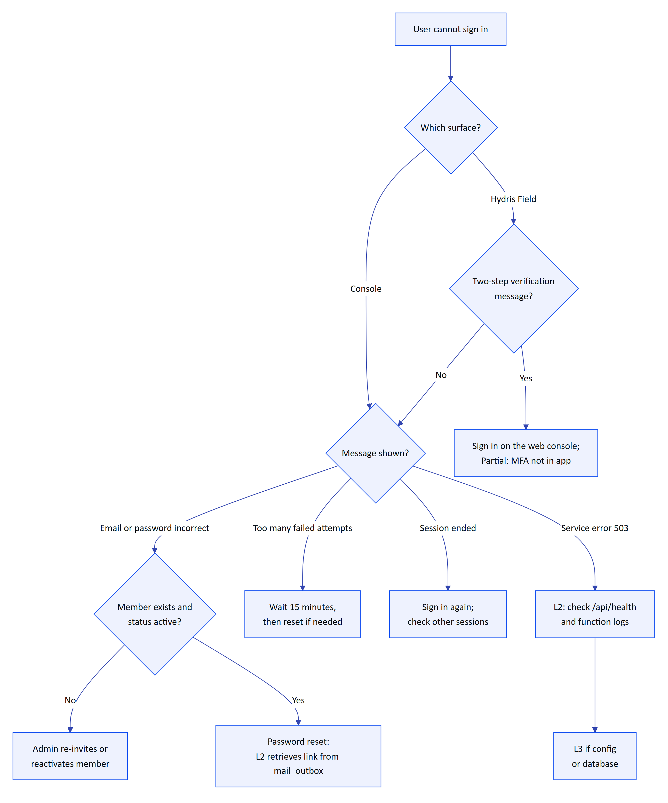
Figure 15. Troubleshooting tree for a user who cannot sign in
Password reset links expire after 30 minutes (TTL.resetMs). Because email is not wired, L2 confirms the request with the customer admin, reads the latest reset link for that address from mail_outbox, and gives it to the user over a verified channel. Delete the row afterwards.

8.3 Pairing fails or code expired
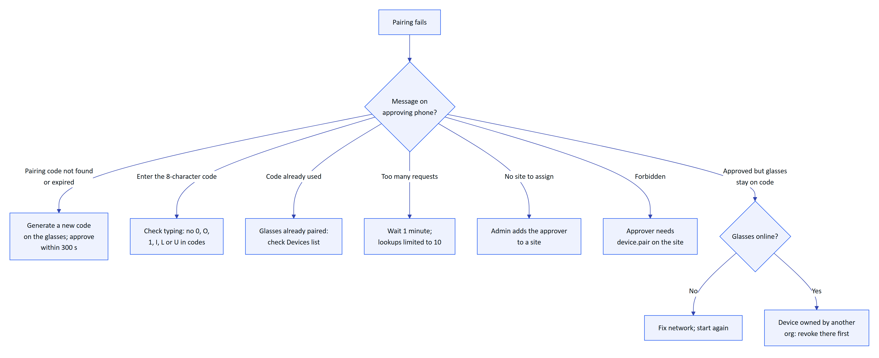
Figure 16. Troubleshooting tree for pairing failures
Common causes in pilots: the approver walked to a desk and took longer than five minutes; the approver has no site in scope; the glasses lost Wi-Fi while polling. After approval, if the glasses show "No operator is assigned to this device" (device_unassigned), assign an operator in the console.

8.4 Glasses not connecting (Ray-Ban Meta)
Messages in Hydris Field (apps/android/app/src/main/java/ai/hydris/field) point to the step that failed: "Install the Meta AI app and pair your glasses in it first", "Connect Hydris in the Meta AI app first (Glasses, Connect)", "Camera permission denied in Meta AI", "The glasses are not registered".
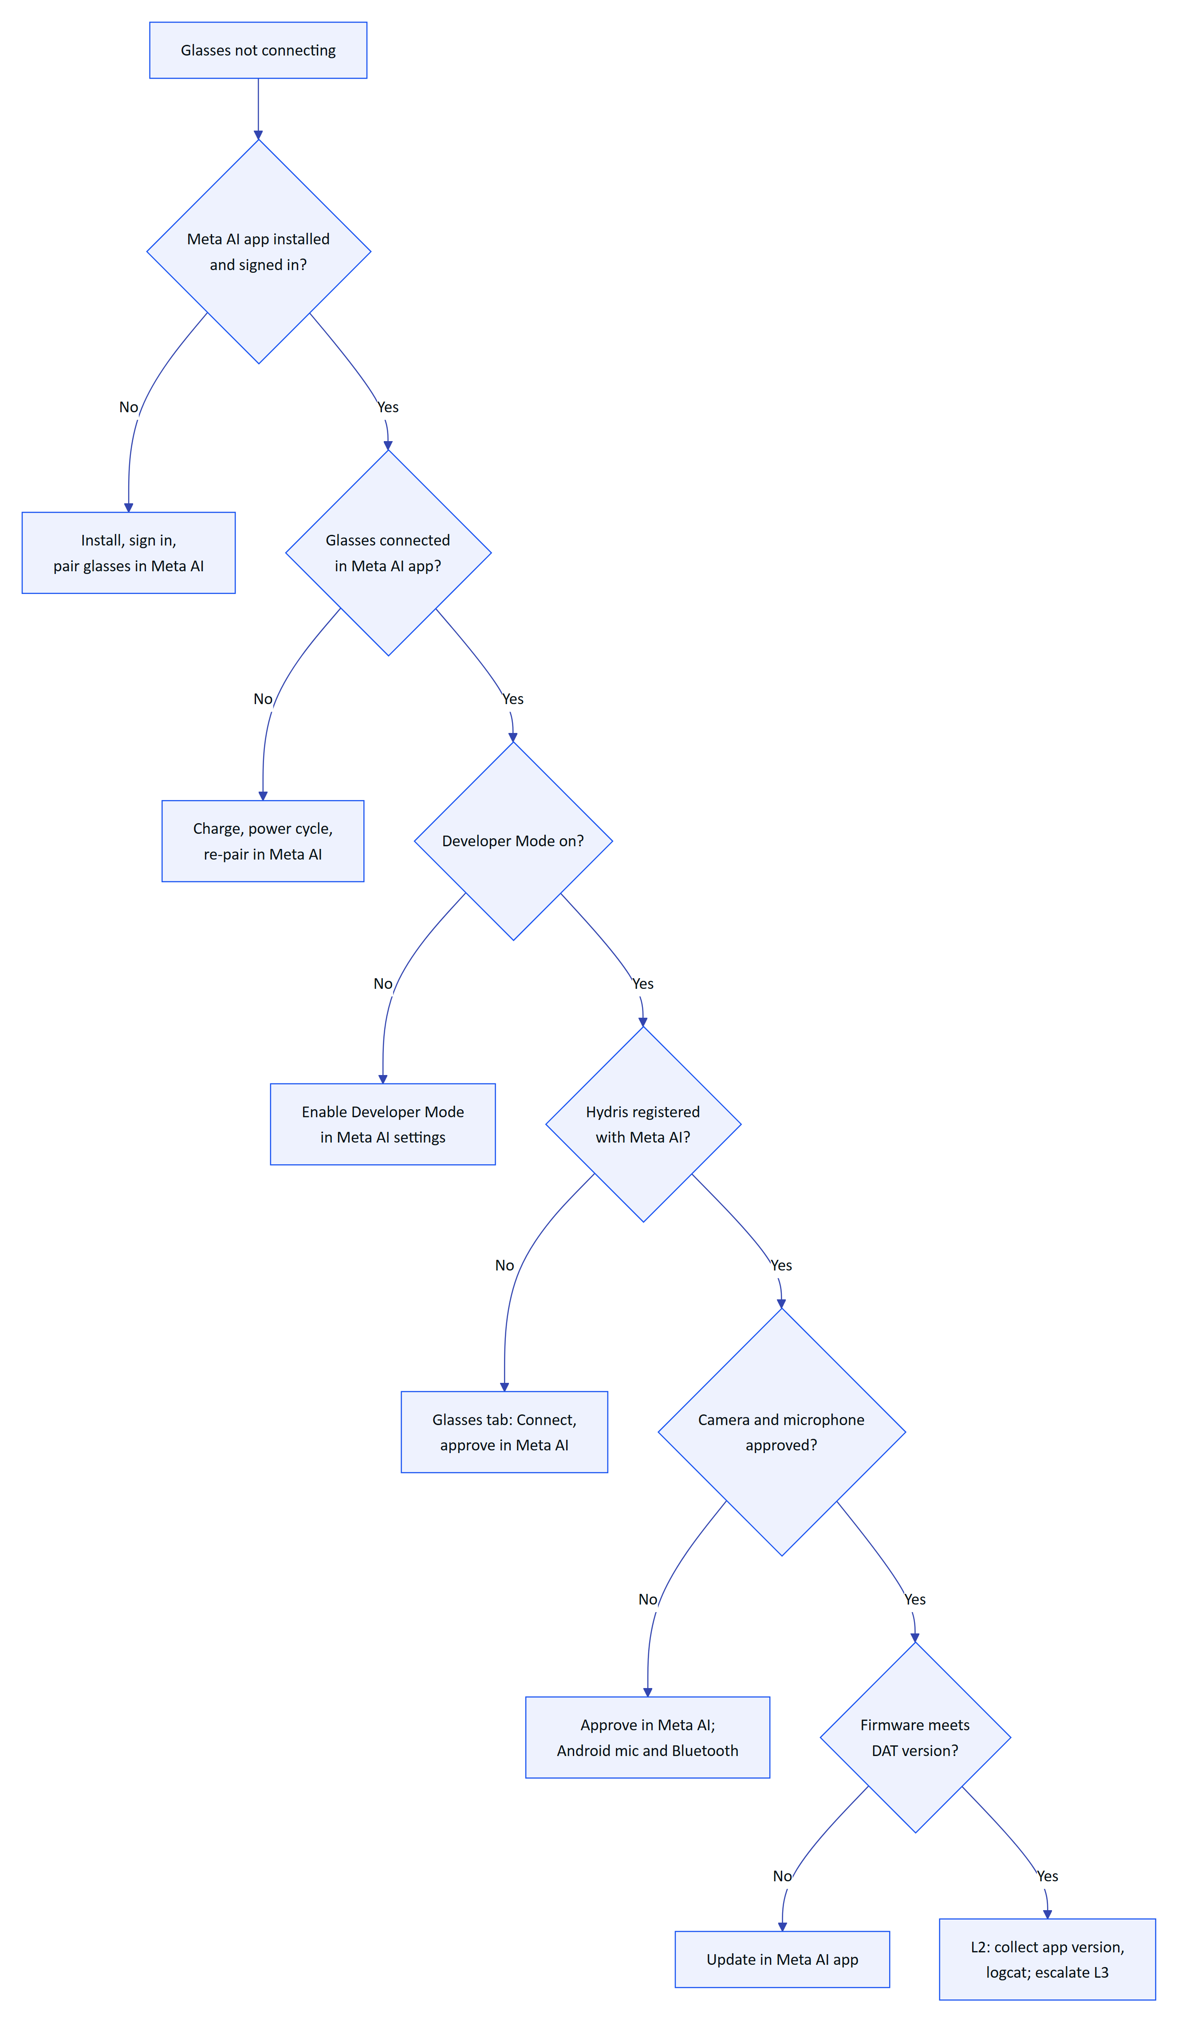
Figure 17. Troubleshooting tree for Ray-Ban Meta glasses that will not connect

8.5 Camera not available
The camera can come from the glasses (DAT stream) or, as a fallback, the phone. Messages: "Glasses camera not available", "Camera unavailable: ...", "Camera permission is needed to scan with the phone", "No usable camera on this phone". On display glasses and the web app, the browser camera permission applies (apps/web/src/glasses/camera.ts).
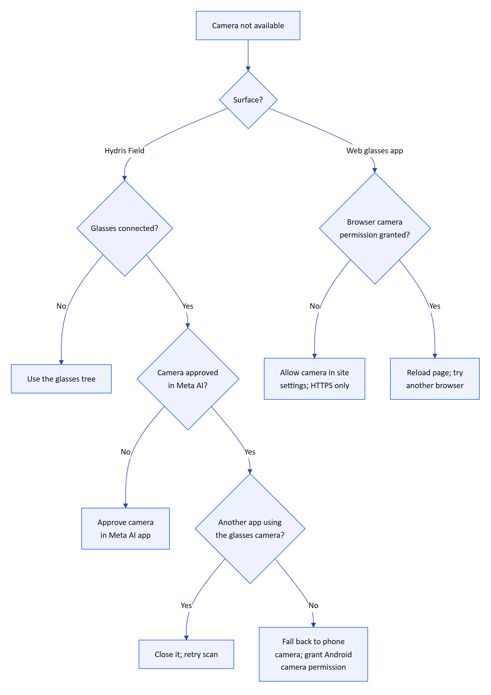
Figure 18. Troubleshooting tree when the camera is not available for a scan

8.6 OCR results are poor
Guided capture checks the page before it auto-captures (DocDetect.kt): it asks the wearer to move closer if the page covers less than 28 percent of the frame, to move back if it touches the edge or covers more than 92 percent, to rotate to portrait, to straighten if a corner is skewed more than 10 degrees, to level if tilted more than 8 degrees, to flatten if the shape is far from A4, and to hold still if the image is not sharp. It then warps the page to a flat A4 image at about 200 dpi.
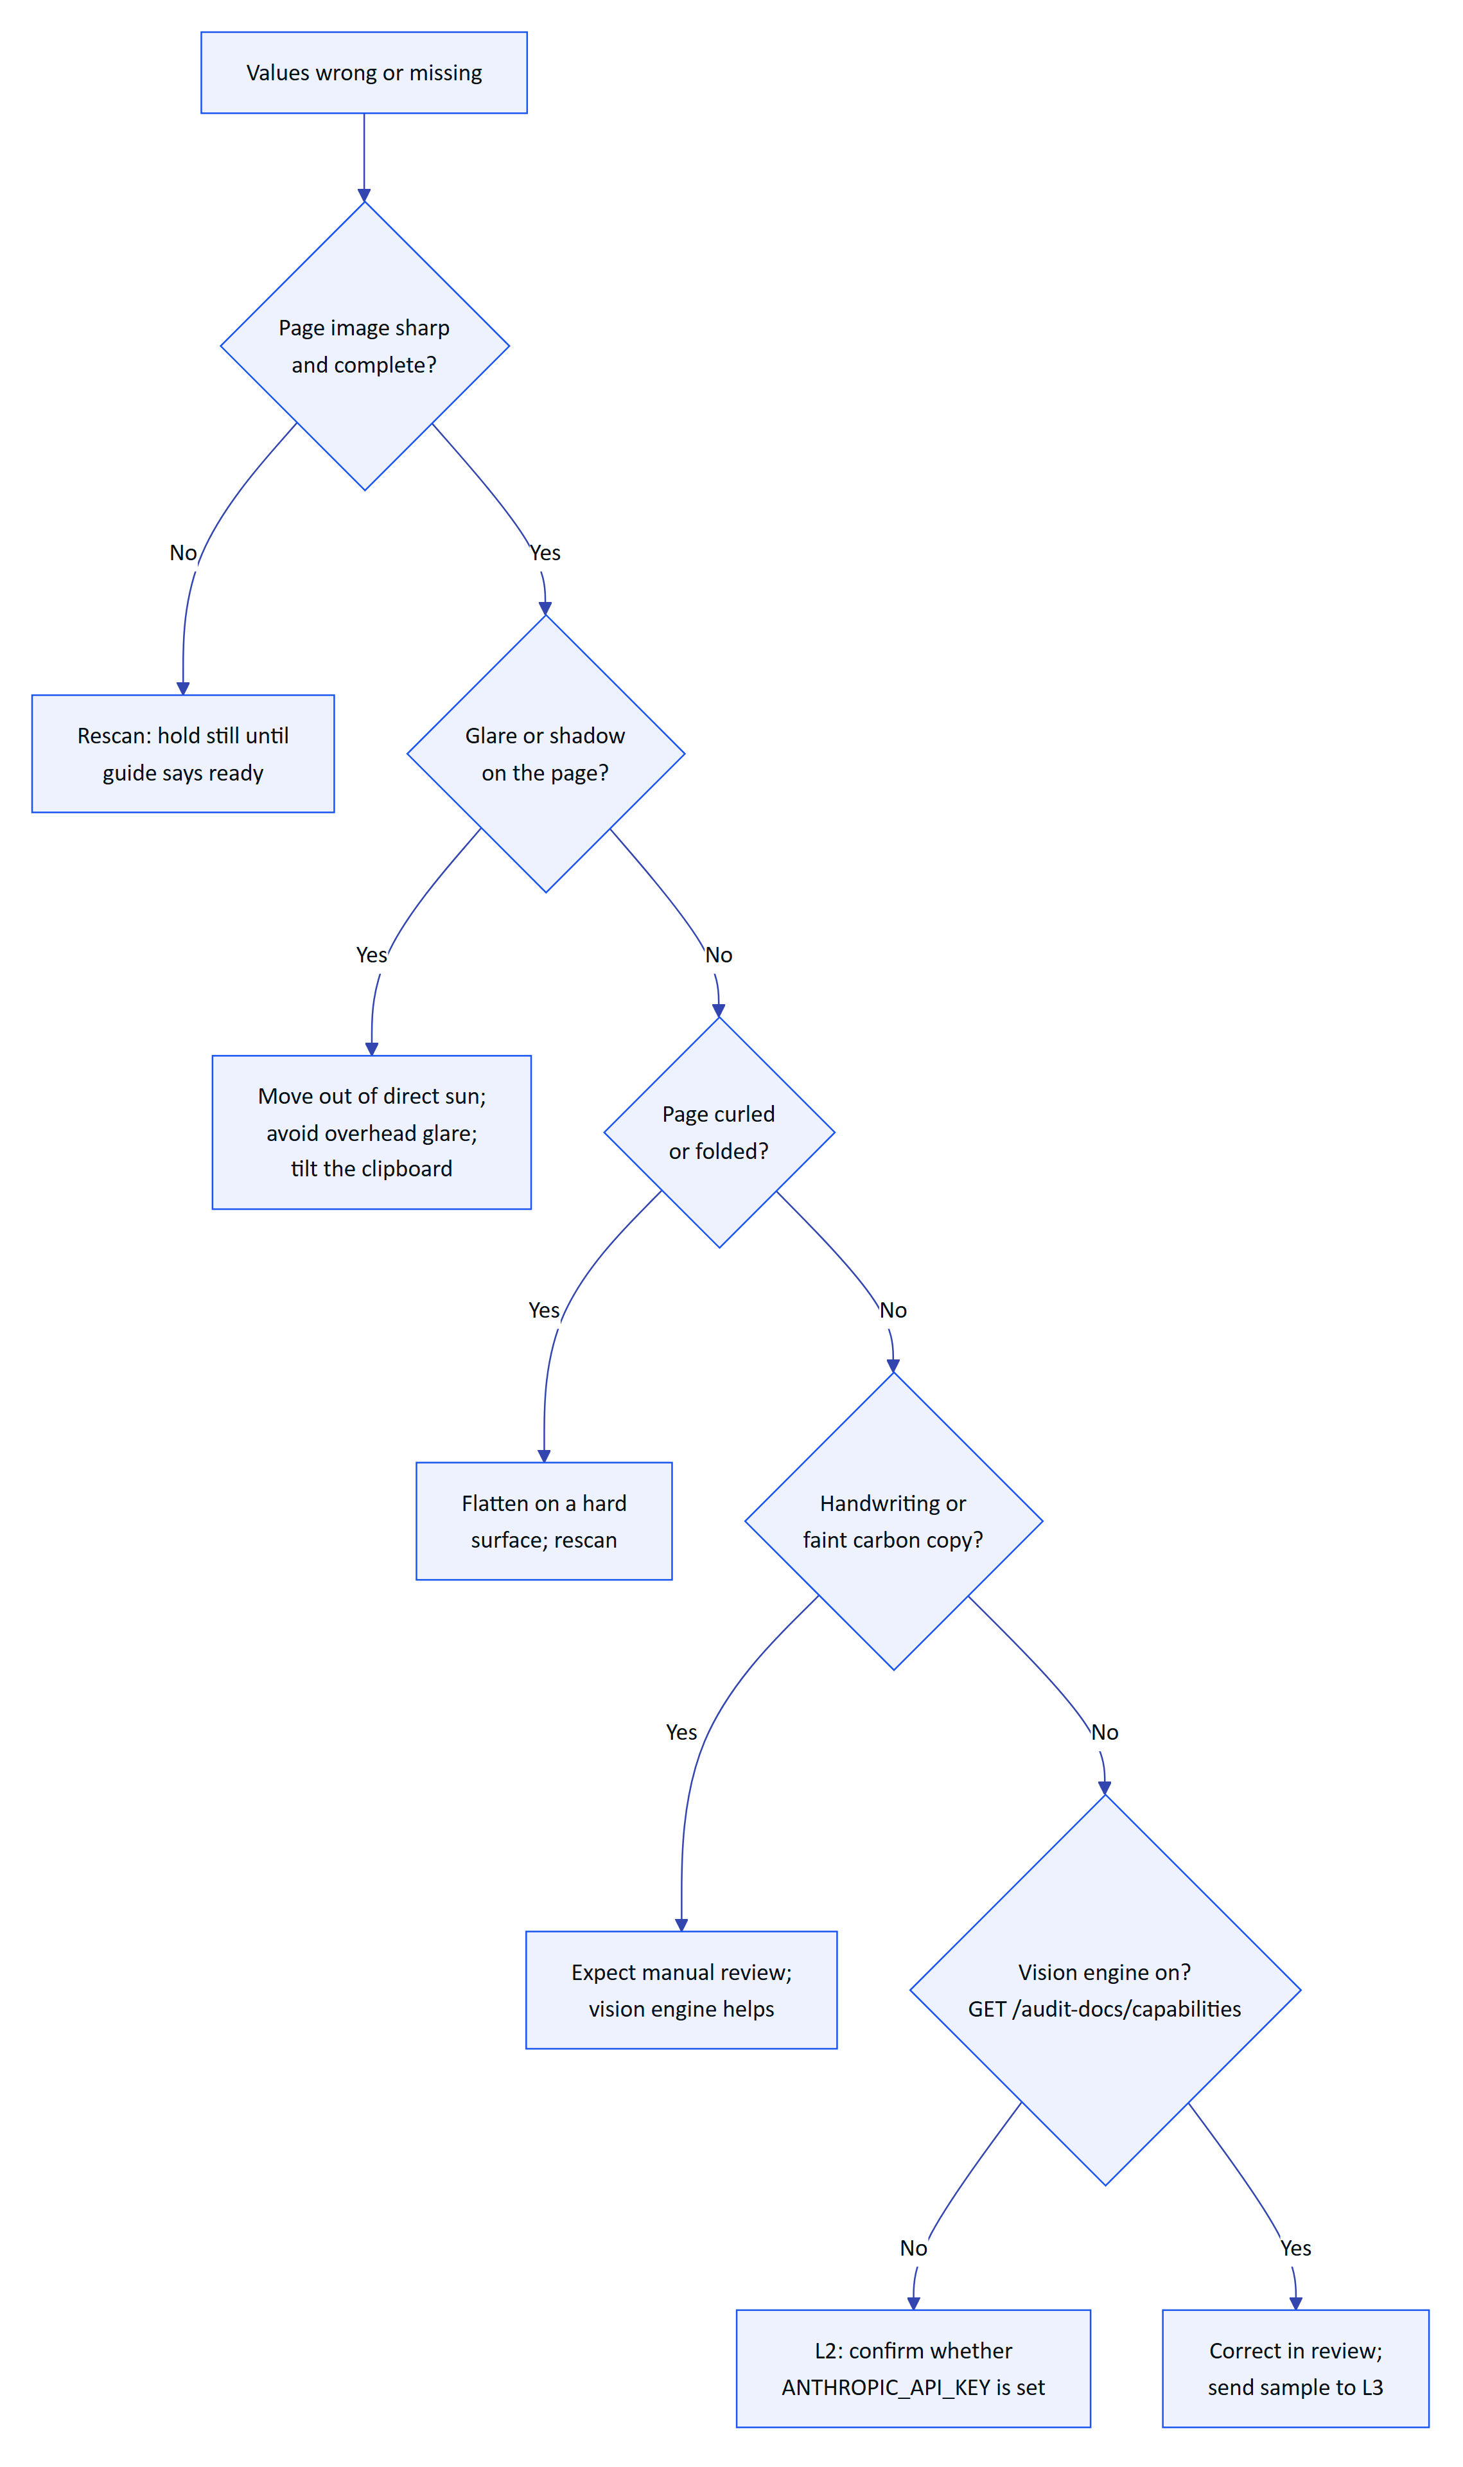
Figure 19. Troubleshooting tree for poor OCR results on audit documents
Correcting values in review is normal and expected; the two-person rule exists because OCR is never perfect. Tell operators that a poor scan costs the reviewer time, so a ten-second rescan is cheaper than a ten-minute correction.
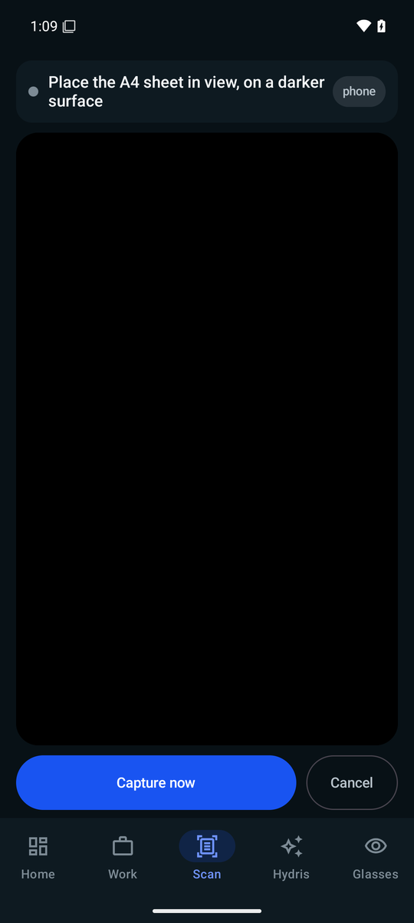
Figure 20. Guided capture on the phone

8.7 Voice assistant not hearing
"Hey Hydris" uses the glasses microphone (DAT speech) when the glasses are connected and the phone microphone through Android SpeechRecognizer otherwise. Answers play through text to speech on the glasses speakers when they are the Bluetooth audio device (apps/android/app/src/main/java/ai/hydris/field/voice/VoiceEngine.kt). The wake phrase is matched on the transcript on the device; only the question after it is sent to POST /api/assistant/ask. Without an Anthropic key, a deterministic intent engine answers measurements, alarms, my work, asset status and procedures, and says it cannot answer anything else.
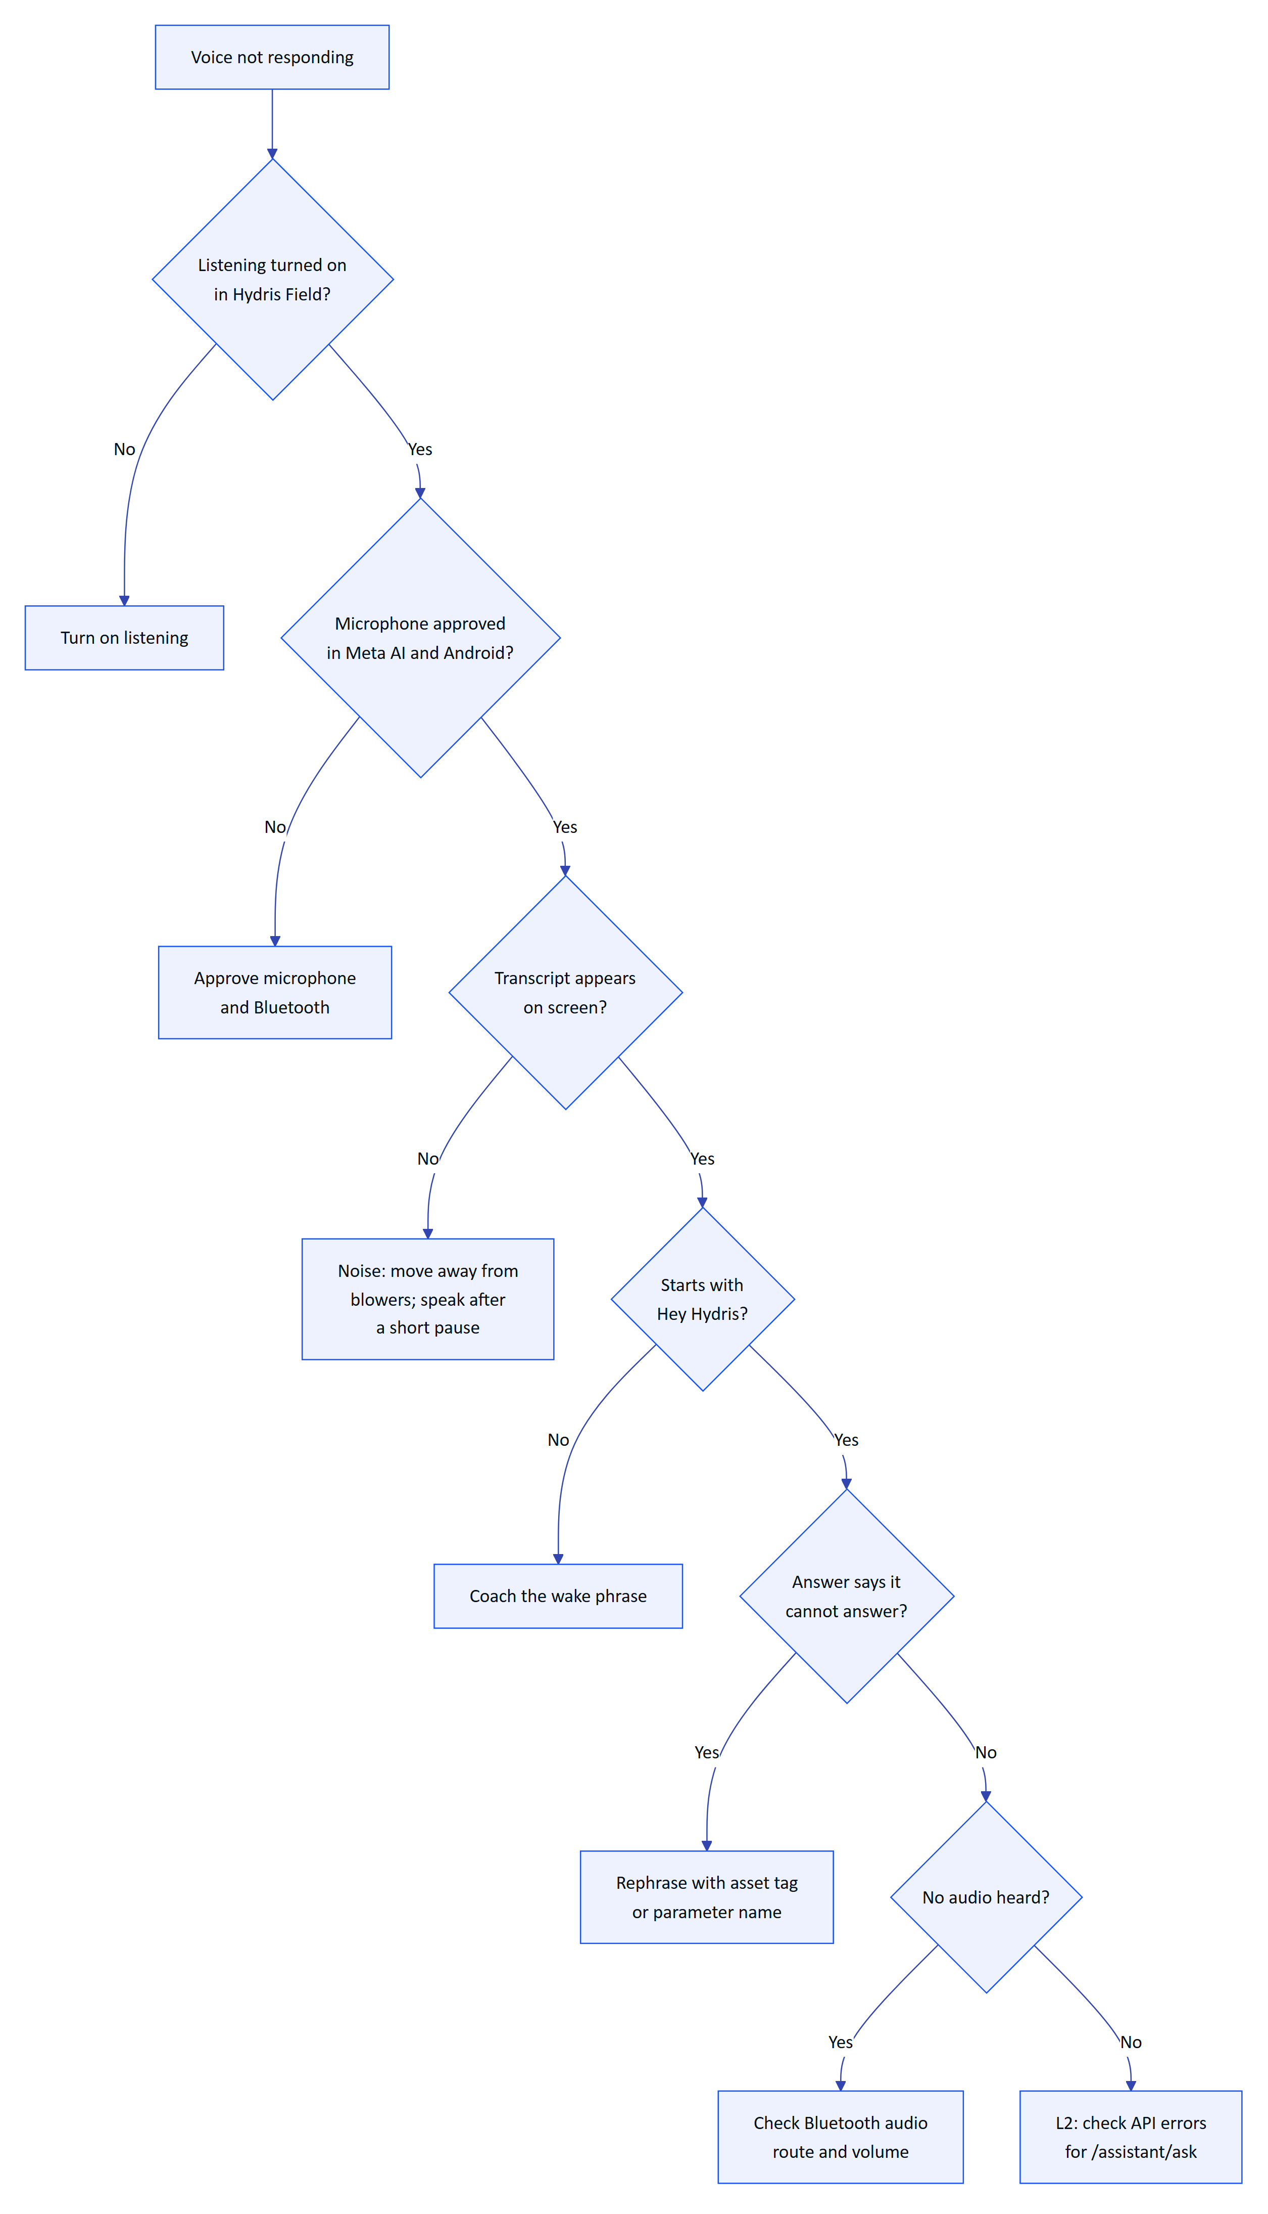
Figure 21. Troubleshooting tree when the voice assistant does not respond
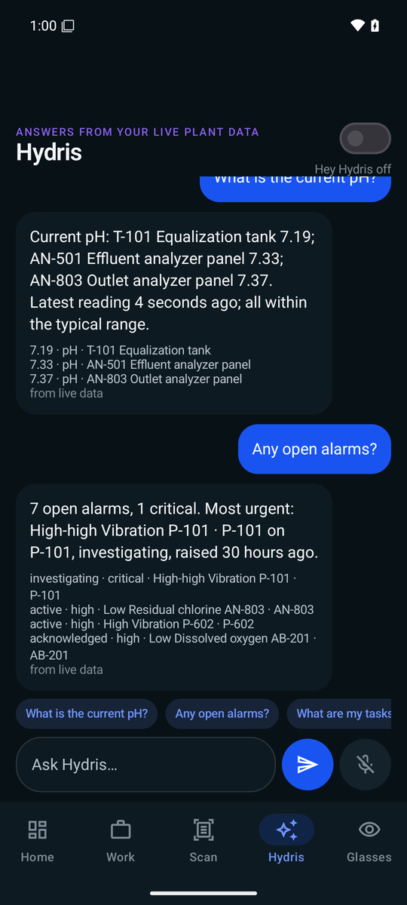
Figure 22. Voice assistant screen on the phone

8.8 Data not updating (telemetry stale)
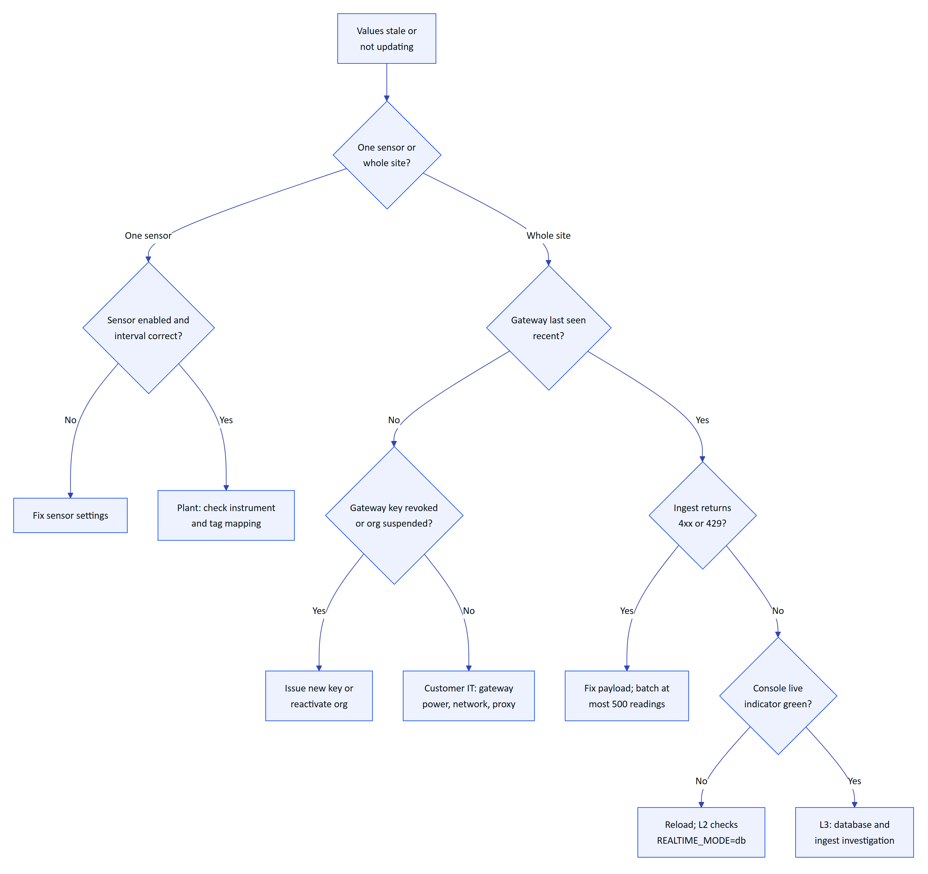
Figure 23. Troubleshooting tree for telemetry that is stale or not updating
Two behaviours to remember:
- On Vercel, stale-data rules are evaluated only when /api/cron runs. vercel.json schedules it daily at 03:00 UTC (0 3 * * *), so a stale alarm can take up to a day to appear on the hosted deployment. The console's freshness badges are computed on read and are always current. On a long-running container the job runs every 30 seconds (apps/api/src/jobs.ts).
- In REALTIME_MODE=db, the console polls the realtime_events table, so updates can lag by about 1.5 seconds. That is normal.

8.9 Console slow
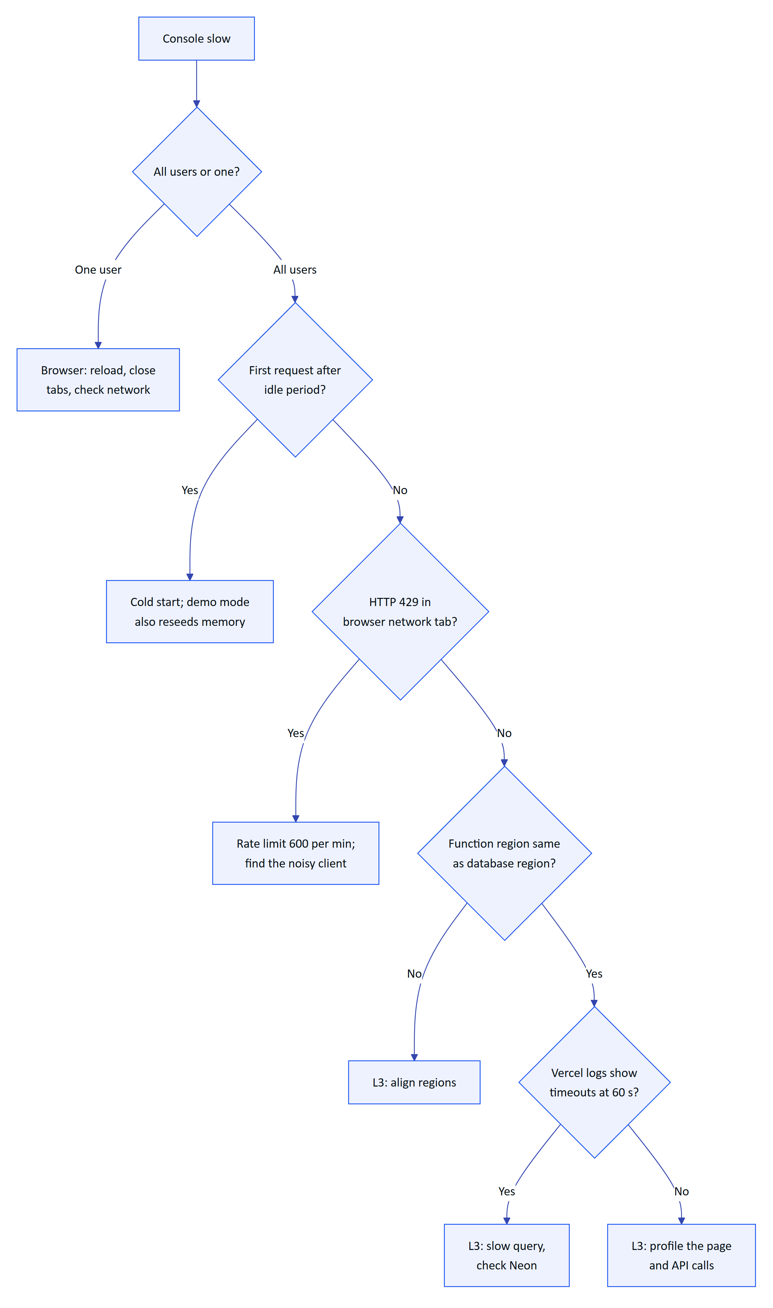
Figure 24. Troubleshooting tree for a slow operator console

9 Incident management

9.1 Severity levels
Table 11. Incident severity levels (targets)
Severity | Definition | Examples | Response | Customer update
Sev 1 | Platform down or data at risk for one or more customers | /api/health failing; cross-tenant data exposure; data loss | L3 engaged within 15 minutes, all hands | Within 1 hour, then hourly
Sev 2 | Major function down for a customer, no workaround | No telemetry ingest; nobody can pair; audit approval broken | L3 engaged within 1 hour | Within 2 hours, then every 4 hours
Sev 3 | Function degraded, workaround exists | Voice down but console works; one site's gateway down | Next business day | Daily
Sev 4 | Minor or cosmetic | Label wrong, slow export | Planned release | On release

A suspected security or personal data breach is always Sev 1 until ruled out and follows SECURITY_PRIVACY.md: customers within 24 hours, CERT-In within 6 hours for reportable incidents, the Data Protection Board and affected data principals per the DPDP Rules, and GDPR authorities within 72 hours where applicable.

9.2 Incident lifecycle
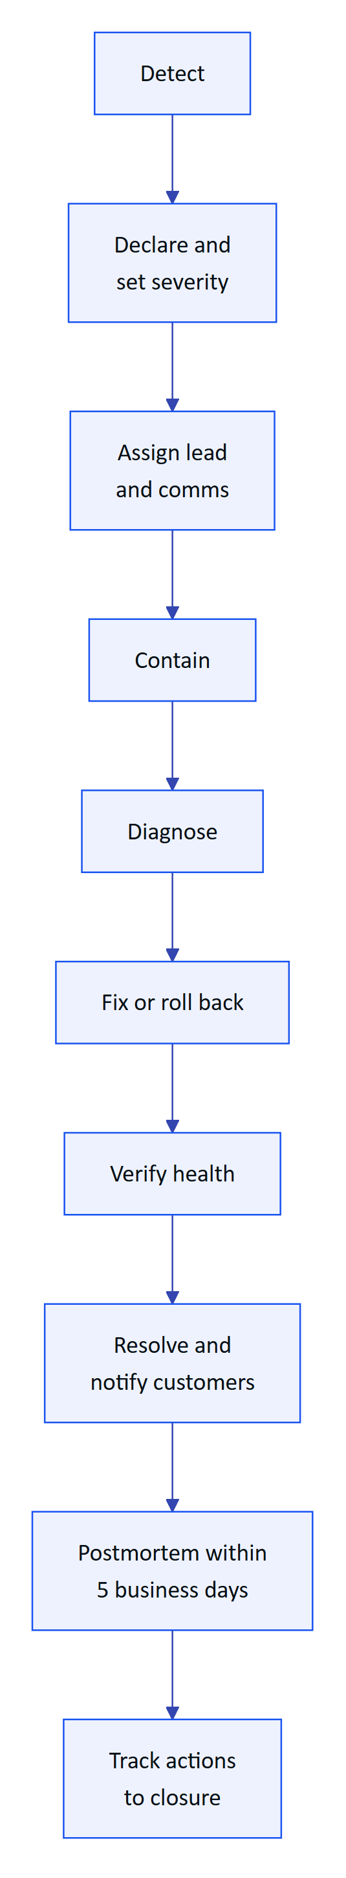
Figure 25. Incident lifecycle from detection to postmortem
Containment levers available today (all Built): revoke a user session (DELETE /api/auth/sessions/:id), suspend or revoke a device, revoke a gateway (POST /api/gateways/:id/revoke), suspend an organisation (POST /api/platform/organizations/:id/status), roll back the Vercel deployment, and as a last resort rotate JWT_SECRET, which signs everyone out. Never rotate DATA_KEY without re-encrypting MFA secrets: losing it disables MFA for every user.

9.3 Communication templates
Initial notice (within the update target for the severity):
Subject: [Hydris] Sev <n> incident: <short description>

We are investigating an issue affecting <surface> for <customer or "some customers">
since <time, time zone>. Impact: <what users see>. Plant equipment and control
systems are not affected; Hydris is read-only to the plant.

Workaround: <if any, otherwise "none yet">.
Next update: <time>.
Incident lead: <name>, Hydris.
Update:
Subject: [Hydris] Update <n>: <short description>

Status: <investigating | identified | fix in progress | monitoring>.
What we know: <one or two sentences>.
What we are doing: <one or two sentences>.
Next update: <time>.
Resolution:
Subject: [Hydris] Resolved: <short description>

The issue affecting <surface> was resolved at <time>. Duration: <duration>.
Cause: <one sentence>. Data: <"no data was lost" or what was affected and how
it was recovered>. A postmortem will follow by <date>.

9.4 Postmortem template
Title, date, severity, incident lead, authors

Summary: two or three sentences a plant manager can understand.
Impact: customers, sites, users, duration, data affected.
Timeline: detection, declaration, key actions, resolution (with time zone).
Root cause: technical cause and contributing factors.
Detection: how we found out; how we should have found out sooner.
What went well / what went badly.
Action items: owner, due date, ticket link. Blameless language throughout.

10 Monitoring and health checks

10.1 Health endpoint
Built. GET /api/health returns {"ok": true, "time": "<ISO timestamp>"} (apps/api/src/app.ts). It confirms that the function starts and the API is registered. It does not prove that the database is reachable; for that, check that the console overview loads, or call an authenticated endpoint such as GET /api/overview. An external uptime check on /api/health is Planned; until then L2 runs it in the daily check.

10.2 Scheduled jobs
Built. runScheduledJobs (apps/api/src/jobs.ts) performs one pass of: stale-data rule evaluation, pairing challenge expiry, pruning realtime_events older than 24 hours (apps/api/src/core/events.ts), and one simulation step for each running scenario when SIMULATOR_ENABLED=true.
Table 12. Background jobs by deployment type
Job | Long-running container | Vercel
Stale-data rules | Every 30 s | On each /api/cron run
Pairing expiry | Every 60 s | On each cron run (challenges also expire on poll and lookup)
Realtime pruning | Hourly when REALTIME_MODE=db | On each cron run
Simulation | Continuous, resumes running scenarios at start | One step per cron run, or lazily per request in demo mode

The cron route (apps/web/src/app/api/cron/route.ts) accepts only Authorization: Bearer $CRON_SECRET and returns {"ok": true, "ms": <duration>, "report": {...}}. A 401 means CRON_SECRET is missing or changed. A report field that starts with error: names the failing job.
DECISION
The schedule in vercel.json is daily (0 3 * * *). For a production pilot with live telemetry, stale alarms evaluated once a day are not acceptable. Before a production pilot, either move to a plan that allows a per-minute cron (* * * * *) or call /api/cron every minute from an external scheduler with the secret. Owner: L3. Status: open.

10.3 Signals to watch
Table 13. Monitoring signals and where to find them today
Signal | Source today | Threshold to act (target) | Status
API up | /api/health | Any failure | Built (manual check)
Cron success | Vercel cron log JSON | Any error: field | Built (manual check)
5xx rate | Vercel function logs | More than 1 percent over 15 minutes | Partial (no alerting)
Refresh token reuse | audit_events actions auth.refresh_reuse_detected, device.refresh_reuse_detected | Any | Built (query)
Login failures | audit_events action auth.login_failed | Spike against baseline | Built (query)
Ingest lag | Sensor freshness on Telemetry | Any critical sensor stale | Built
Tracing, error tracking, uptime alerts | OpenTelemetry, Sentry, uptime monitor |  | Planned

11 Data requests

11.1 Exports
Built. All exports are scoped to the caller's organisation and sites, and CSV exports are audited (report.exported).
Table 14. Data export paths
Data | Path | Permission
Alarms, inspections, maintenance, devices, operators | GET /api/reports/:kind?format=csv | report.export
Sensor readings | GET /api/telemetry/sensors/:id/export.csv | telemetry.read
Approved audit document with trail | GET /api/audit-docs/:id/pdf | auditdoc.read
Audit log | GET /api/audit (console Audit) | audit.read
Change history of an entity | GET /api/history/:entityType/:entityId | Read permission on the entity

A full tenant export (all tables, all files) is Planned; until then L3 produces it from the database on a signed request from the customer admin.

11.2 Deletion and DPDP requests
India's DPDP Act 2023 and the DPDP Rules 2025 give data principals rights to access, correction and erasure, and to grievance redressal. For a plant, most personal data is the names and emails of members, IP addresses in sessions and audit events, and names attached to records.
Table 15. Handling data principal requests
Request | Procedure | Status
Access | Customer admin exports member record and their activity (/api/audit filtered by user); L2 assists | Partial (manual)
Correction | Member updates their name in Account; admin updates title and role | Built
Stop access | Admin deactivates the member (PATCH /api/members/:userId) and revokes their devices | Built
Erasure | No self-service deletion. L3 pseudonymises the user record on written request after legal review. Records that form part of a regulated record (alarm notes, inspection sign-offs, audit document approvals) are kept with the customer's retention period and the name pseudonymised where the law allows | Planned (manual today)
Grievance | Logged as a P2 ticket; answered within the statutory period | Built (process)

CAUTION
Hydris is usually the processor; the customer is the data fiduciary. Act on a data principal's request only through the customer admin, unless the request concerns Hydris's own website inquiries (/public/inquiries, where Hydris is the fiduciary). Never hard-delete audit trails: audit_events, telemetry_corrections and audit_document_events are append-only by design.

12 Demo environment management
Built. Demo mode turns on when DEMO_MODE=true, or automatically on Vercel when no DATABASE_URL is set (isDemoEnv in apps/api/src/config.ts). In demo mode:
- Each serverless instance runs its own in-memory database seeded with the same deterministic synthetic tenant. A cold start resets it. DEMO_PERSIST=true with a Postgres URL seeds into Postgres instead.
- Built-in public demo secrets are used if none are configured, and a warning is logged. Demo mode must never hold real plant data.
- "Enter demo mode" asks for a name and creates a personal guest account (POST /api/auth/demo, apps/api/src/core/demo-guests.ts): an org admin on all sites with its own copy of open inspections and maintenance tasks. The same name always maps to the same account. Guest names are kept for 30 days.
- State that must survive across instances (pairing challenges and approvals, guest names) goes into a shared store (apps/api/src/core/demo-shared.ts): Postgres when available, otherwise Vercel Runtime Cache, otherwise process memory.
- Access tokens last 12 hours, the simulator is on and the realtime mode is db.
- Self-approval of audit documents is allowed and recorded as such.
Before a sales demo (L1 or sales engineer):
- ☐ Open the demo URL 10 minutes early to warm an instance
- ☐ Enter demo mode with the presenter's name; check the overview loads
- ☐ Start a scenario on /simulator (for example pump_vibration) and confirm an alarm appears
- ☐ Pair the simulator or phone glasses view and confirm the operator's name shows
- ☐ Run one audit scan end to end
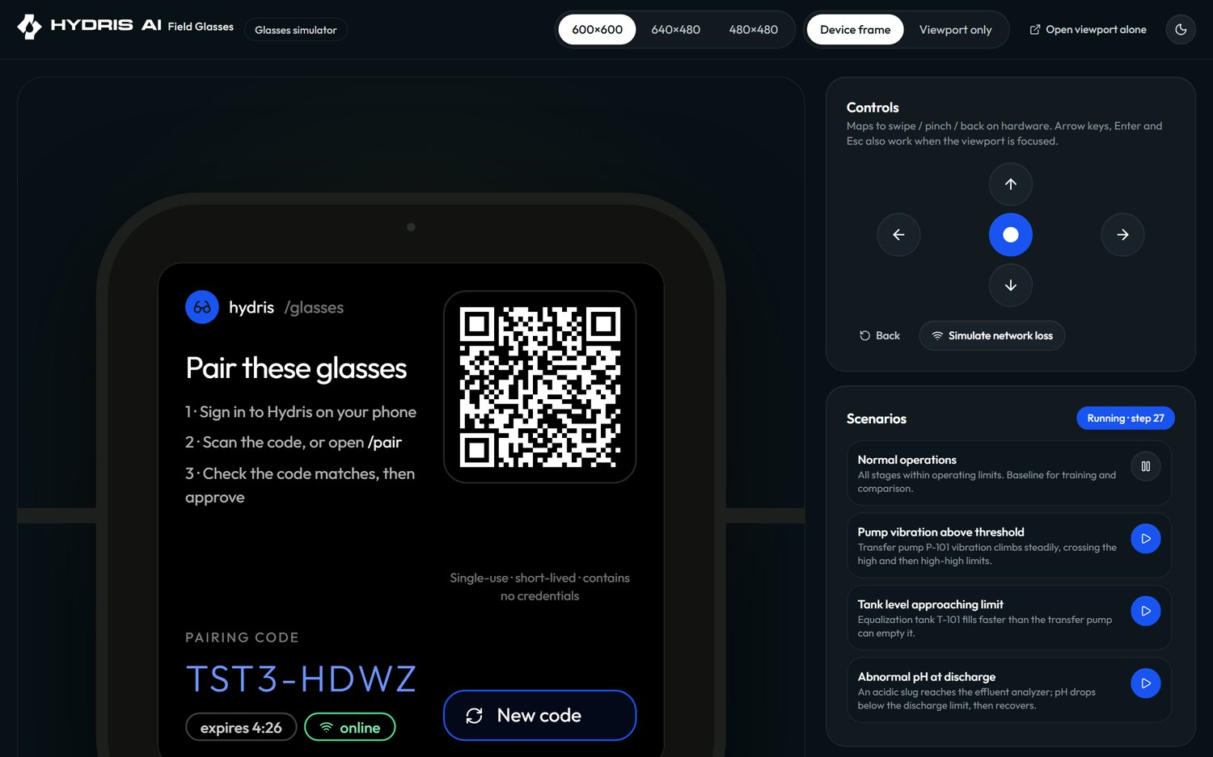
Figure 26. Simulator used in demos
If the demo misbehaves mid-session, reload: a new instance reseeds. Do not try to repair demo data. For a customer who wants a longer evaluation, set up a separate Postgres-backed tenant with npm run seed:demo rather than relying on the in-memory demo.

13 Release and change management

13.1 Environments and the path to production
DEPLOYMENT.md defines dev (local, PGlite), preview (per pull request), staging and production. Vercel deploys previews per pull request and production from main. There is no CI configuration in the repository yet, so the checks below are run by the releasing engineer (Partial).
Pre-release checklist (L3):
- ☐ npm run typecheck, npm test and npm run build pass locally
- ☐ npm run test:e2e (Playwright) passes against the preview
- ☐ Migrations reviewed: additive only, or a written plan for destructive steps
- ☐ Preview deployment smoke test: sign in, overview, pairing via /simulator, alarm transition, audit scan
- ☐ Release note written for customers if behaviour changes
- ☐ Android: new APK tested on the spare kit if the API contract changed
Migrations run on the first request of each new function instance under a Postgres advisory lock, or during the build with npm run vercel-build and MIGRATE_ON_START=false (docs/operations/vercel.md).

13.2 Maintenance windows
Table 16. Change classes and windows (targets)
Change | Window | Notice to customers
Web and API release, no migration | Any time outside shift changes | Release note after
Release with additive migration | Weekdays 14:00 to 16:00 IST | 2 business days
Release with destructive migration or data backfill | Sunday 06:00 to 08:00 IST | 5 business days
Android APK rollout | Between shifts, per site | 2 business days
Glasses firmware | Between shifts, after spare-kit test | 2 business days
Secret rotation (JWT_SECRET, CRON_SECRET) | Planned window or incident | Users will need to sign in again for JWT_SECRET

13.3 Rollback
- Web and API: promote the previous production deployment in Vercel (instant rollback). Because migrations are additive, the previous code runs against the newer schema.
- Destructive migration: do not roll back code alone. Restore from Neon point-in-time recovery to a branch, verify, then switch; this is an L3 decision and a Sev 2 incident at least.
- Android: reinstall the previous APK (kept with every release).
- UI profile: use Rollback on the profile (POST /api/ui-profiles/:id/rollback); glasses reload the earlier version.
- Alarm rule change: edit the rule back; the audit log shows the previous values.

14 Training curriculum

14.1 Curriculum
Table 17. Training modules by audience
Module | Audience | Duration | Format | Covers
Platform overview | All | 30 min | Classroom | What Hydris does and does not do; read-only to the plant
Glasses basics | Operators, maintenance | 45 min | Hands-on | Wearing, charging, Hydris Field home, work list, alarms on glasses
Guided capture | Operators | 45 min | Hands-on on real log sheets | Lighting, flattening, holding still, multi-page scans
Hey Hydris | Operators, maintenance | 30 min | Hands-on on the floor | Wake phrase, asking by tag, limits of the assistant
Alarm handling | Operators, supervisors | 45 min | Scenario on simulator | Acknowledge vs resolve, notes, escalation matrix
Inspections and maintenance | Operators, supervisors | 45 min | Hands-on | Executing routes, checklists, requesting maintenance
Review and verification | Supervisors, managers | 60 min | Hands-on in console | Review queue, bulk confirm, verify, approve, reject, PDF
Fleet administration | Customer admin, supervisors | 45 min | Hands-on | Pairing approval, assign, suspend, revoke, UI profiles
Tenant administration | Customer admin | 90 min | Workshop | Sites, assets, sensors, gateways, users, roles, SOPs, reports
Support and escalation | Customer admin, supervisors | 30 min | Classroom | When and how to contact Hydris, what to include

14.2 Operator journey
The journey below shows the target experience for an operator in their first week, with scores from 1 (poor) to 5 (good) as the expected experience, to be validated in the pilot.
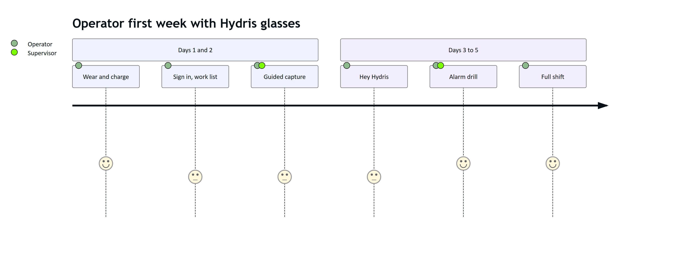
Figure 27. Operator learning journey in the first week (expected experience)
Sign-off: an operator is signed off after one full shift in which they completed an inspection route, scanned at least one document that was verified without a rescan, and acknowledged a drill alarm. Supervisors are signed off after verifying five documents and completing a pairing approval and a device reassignment.

15 Operations KPIs
All values are targets for the first pilot. Measurement sources are named so the numbers can be produced from the product rather than estimated.
5 min  Time to pair  Target from code shown to Connected |  | 1 day  Scan to verified  Target for routine records |  | 5 min  Critical alarm acknowledge  Target, median |  | 99.5%  Monthly availability  Target for /api/health

Table 18. Operations KPIs, targets and measurement sources
KPI | Target | Measured from
Time to pair (challenge created to device connected) | Median under 5 minutes | pairing_challenges.created_at to completed_at; device last_seen_at
Pairing success on first code | Over 90 percent | Completed vs expired challenges
Scan to verified | Median 1 business day | audit_documents.created_at to verified_at
Verified to approved | Median 2 business days | verified_at to approved_at
Rescan rate | Under 10 percent of documents | Rejected documents over total
Critical alarm acknowledge time | Median under 5 minutes | Alarm events (raised to acknowledged)
High alarm acknowledge time | Median under 15 minutes | Alarm events
Alarms resolved with a note | 100 percent (enforced in code) | requiresNote on resolve
Sensors live | Over 98 percent of sensor-hours | Freshness on telemetry history
Devices connected on shift | Over 95 percent | Device report
Support first response | Per priority table | Ticket system
Platform availability | 99.5 percent monthly | External uptime check (Planned)

16 Support contact and escalation templates
Support contacts are confirmed per customer at kickoff and recorded in the customer's account plan.
Table 19. Support contact details (to be completed per customer)
Channel | Use | Hours
Support email (to be confirmed) | P3 and P4 tickets | Business hours IST
Support phone (to be confirmed) | P1 and P2 | 24 by 7 for P1 during pilots (target)
Shared chat channel | Day-to-day coordination | Business hours IST
Customer success manager | Account, training, KPIs | Business hours IST

Customer admin to Hydris (ticket template):
Subject: [<Customer> / <Site>] <P1-P4>: <short description>

Who is affected: <user emails or "all users at site X">
Surface: <console | glasses web app | Hydris Field app> <app version if known>
Device: <device name from the Devices page, if relevant>
Since: <date and time, time zone>
What happened: <steps and the exact message shown>
What we tried: <steps from the runbook>
Screenshots: attached (no passwords, codes or keys)
L1 to L2 or L3 escalation:
Ticket: <id> Priority: <P1-P4> Customer: <name> Site: <name>
Summary: <one sentence>
Evidence: <health result, cron report, log lines with timestamps, request ids>
Runbook trees followed: <names and where they ended>
Suspected area: <auth | pairing | devices | telemetry | audit docs | voice | infra>
Customer impact and workaround: <text>
Ask: <what you need from the next tier>

17 Appendices

17.1 Glossary
Table 20. Glossary
Term | Meaning
DAT | Meta Wearables Device Access Toolkit; the SDK Hydris Field uses to reach Ray-Ban Meta glasses
Developer Mode | Meta AI app setting that lets an unpublished app such as Hydris Field register with the glasses
Device token | Access and refresh tokens issued to a paired glasses device, separate from user sessions
Freshness | Live, delayed, stale or no data, derived from a sensor's expected interval
Gateway | Plant-side system that posts readings with an hgw_ key
Pairing challenge | Short-lived (300 s), single-use code that links glasses to a site
RLS | Postgres row-level security; isolates tenants at the database
Stale rule | Alarm rule that raises "No fresh data" when a sensor stops reporting
Two-person verification | Verify by one person, approve by a different person (audit documents)
UI profile | Versioned configuration of the glasses screens and actions, assigned by device, user, role or org
Demo mode | Self-contained deployment with synthetic data, guest accounts and in-memory database
DPDP | India's Digital Personal Data Protection Act 2023 and Rules 2025

17.2 Command cheat sheet
Health and cron (replace the domain for other environments):
curl -s https://hydrisview.vercel.app/api/health
curl -s -H "Authorization: Bearer $CRON_SECRET" https://hydrisview.vercel.app/api/cron
Local development, database and seed (repository root):
npm install
npm run dev # API on :4000, web on :3000
npm run db:migrate
npm run seed # needs SEED_ADMIN_EMAIL and SEED_ADMIN_PASSWORD (12+ chars)
npm run seed:demo # also needs SEED_DEMO_PASSWORD (12+ chars)
npm run typecheck && npm test && npm run build
npm run test:e2e
Demo mode locally:
DEMO_MODE=true npm run dev
Reports and exports with a console access token:
curl -s -H "Authorization: Bearer $TOKEN" "https://hydrisview.vercel.app/api/reports/alarms?format=csv" -o alarms.csv
curl -s -H "Authorization: Bearer $TOKEN" "https://hydrisview.vercel.app/api/reports/devices?format=csv" -o devices.csv
curl -s -H "Authorization: Bearer $TOKEN" "https://hydrisview.vercel.app/api/audit-docs/$DOC_ID/pdf" -o audit-doc.pdf
Device actions:
curl -s -X POST -H "Authorization: Bearer $TOKEN" -H "Content-Type: application/json" \
-d '{"reason":"lost on site"}' "https://hydrisview.vercel.app/api/devices/$DEVICE_ID/suspend"
curl -s -X POST -H "Authorization: Bearer $TOKEN" -H "Content-Type: application/json" \
-d '{"reason":"stolen"}' "https://hydrisview.vercel.app/api/devices/$DEVICE_ID/revoke"
Android build, install and logs:
cd apps/android
./gradlew assembleDebug
adb install -r app/build/outputs/apk/debug/app-debug.apk
adb logcat | grep -i hydris
Database checks (L3, read-only role, production only with approval):
select action, at, ip from audit_events
where action in ('auth.refresh_reuse_detected', 'device.refresh_reuse_detected')
order by at desc limit 50;
select status, count(*) from pairing_challenges
where created_at > now() - interval '7 days' group by status;

